

Adapt IT Consulting and Training

INTEGRATOR 4.1 – TRAINING MANUAL

Finance System

Accounts Receivable

Copyright

©All rights reserved

No part of this document may be reproduced or transmitted in any form or by any means, without express written permission from Adapt IT or an authorised representative of Adapt IT. This includes, but not limited to, electronic, electrostatic, magnetic tape or mechanical copying and recording, or use of any information storage and retrieval system.

First edition: February 2018

Disclaimer

Adapt IT makes no representations or warranties with respect to the contents hereof. Although due care and precaution has been taken in the preparation of this manual, Adapt IT assumes no responsibility for errors and omissions or any damages resulting from the use of the information contained in this publication.

Contents

Course Overview 1

Pre-requisite knowledge and skills 1

Course content 1

Learning outcomes 1

Module Structure 2

System Access 3

Logging on to Integrator 3

Landing Page 6

Exiting a form 6

1 System Requirements 8

1.1 Introduction 9

1.2 Maintain Account Type Definition {FCSC-21} 9

1.3 Maintain AR Statement Groups {FARC-4} 10

1.4 Maintain Transaction Type Definition {FCSO-7} 11

1.5 Maintain System Operational Definitions {FCSM-1} 15

1.6 Link Default Statement Groups to Documents {FARM-3} 18

1.7 Update Statement Groups Using Document Defaults {FININS-1} 18

2 Notes 20

2.1 Introduction 21

2.2 Creating a Note 21

2.3 Send Notes Reminder Mail {GOPS-23} 21

2.4 Background Processes {BATCH-9} 23

3 Accounts Receivable Transactions MPM {FARO-14} 25

3.1 Introduction 26

3.2 Invoice {FARO-1} 26

3.2.1 Create Invoice 27

3.3 Cancel Invoice {FARO-5} 39

4 Other Operational Menus 41

4.1 Introduction 42

4.2 Debtor definition pre-requisites 42

4.3 Maintain Debtors {FARO-21} 43

4.4 Query Types of Documents {FCSO-23} 48

4.5 Default text on multiple invoices 49

4.6 Invoices to be Sent {FAROR1-1} 49

4.7 Consolidated External Debtor Statement – NCR Format {FAROR1-12} 52

4.8 Query debtor transactions {FARO-3} 53

4.9 Calculating interest on debtor balances 54

5 Journals 58

5.1 Introduction 59

5.2 Batch journals {FARO-29} 59

5.3 Inter account transfers {FARO-2} 60

5.4 Maintain no show indicators {FARO-4} 62

5.5 Electronic Approval of transactions {FARO-11} 63

5.6 Open item functionality 64

5.6.1 Debtor Transactions {FARI-1} 65

5.6.2 Undistributed Items {FARI-2} 68

6 Reports 75

6.1 Introduction 76

6.2 Print Audit Trail {FARMR1-1} 76

6.3 Print User Work Summary {FARMR1-2} 76

6.4 Balances: Aged {FAROR1-4} 77

6.5 Consolidated Debtor Statement {FAROR1-9} 77

6.6 Consolidated Internal Debtor Statement {FAROR1-11} 78

6.7 Transaction per Type {FAROR1-23} 79

6.8 Print AR Journals in Process {FAROR1-29} 80

Acronyms, Glossary & Terminology 81

Acronyms 81

Glossary 100

Terminology 101

Help us enhance the course 103

# Course Overview

Welcome to the ITS Integrator course for the Accounts Receivable subsystem. This course is designed to equip you with the skills and knowledge you need to administrate sundry debtors. In fact, it is essential for anybody who will be responsible for debt other than student debt.

Course duration

2 days

## Pre-requisite knowledge and skills

Before you can register for this course, you must have attended the interface training so that you have the minimum knowledge of system navigation.

## Course content

The course structure is divided into modules and covers the following:

|  |  |
| --- | --- |
| **Subsystem** | **Modules** |
| Accounts Receivable | * System requirements * Creating notes * Accounts receivable transactions MPM * Other operational menus * Journals * Reports |

## Learning outcomes

On completion of this course, the trainee should be able to:

* Set-up system pre-requisites.
* Create and Maintain notes.
* Utilise the Accounts Receivable Transactions MPM
* Create and maintain journals.
* Generate reports.

## Module Structure

Each module contains the following parts:

**Specific outcomes**

The specific outcomes are very important because they state what is expected of you.

**Introduction**

Each module starts with a statement of the content and learning outcomes for that module in order to introduce you to the subject matter of the module. Suggested time allocation is also indicated. Bear in mind that the time allocation is only a guide and some people will take longer than others to complete the same task. The timeframe can also be longer if you choose to look up content from other resources.

**Content**

Module content consists of information moving from system pre-requisites to operational and menu management issues. The content is subdivided into topics, tasks, procedures and other information arranged in a logical sequence and broken down into small, connected and understandable units. This content can be supplemented by support materials such as PowerPoint presentations, worksheets, hand-outs, etc.

# System Access

## Logging on to Integrator

To access the ITS Integrator system, you need to use the Internet Explorer. Using your browser, use the URL relevant to your institution or link from the institutions’ local Intranet. You will be prompted for your user name and password. Username and passwords are set up in User Access Definitions {USERS-5} and maintained by the institution. A user can have multiple logins with the same user ID. It is dependent on institution rules and policies. Additionally, unsuccessful logging attempts might be limited to a specific number depending on the institution’s policy.

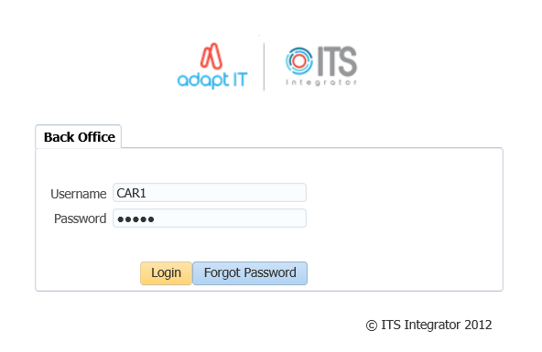

1. Type in your username and password
2. Click on the Login button

**Forgot Password**

If you are having difficulty logging in to Back office or you forgot your password, you can reset your password.

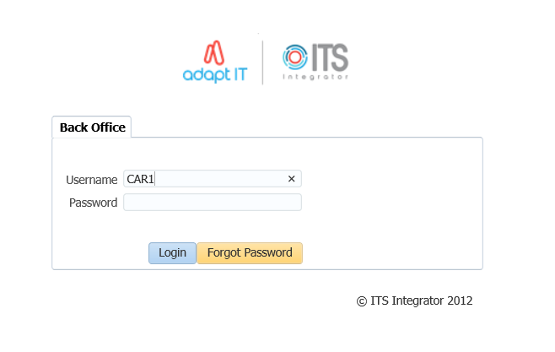

1. Enter your Username
2. Click on the “Forgot Password” button

To be able to reset ITS/OID password, the users email address must be set up on {PBOP-14}/ {GOPS-3} and Primary Indicator for the email must be set to “Y”. If security questions are not set up on {USERS-17}, the user will get login control message to set up password questions and Answers.

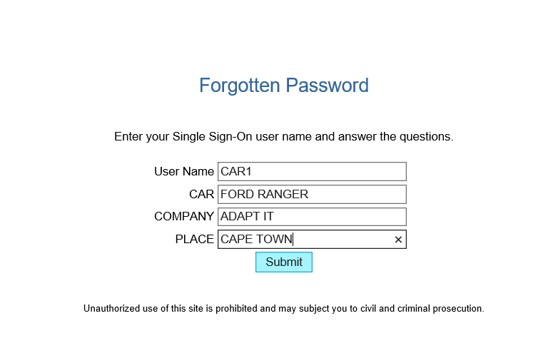

1. Answer the questions as set on {USERS-17}
2. click on “Submit button”

The notification pop up message to be illustrated

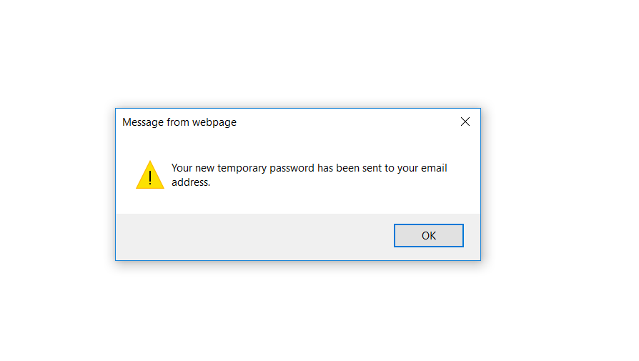

Logging in to ITS Integrator again with the given password on the email



On the main page after logging onto integrator, on the More Tab, the Forgot Password Q and A can be found here and this will direct the user to {USERS-17}

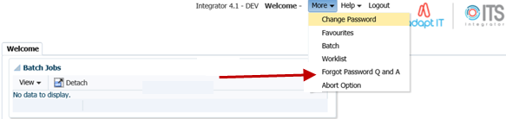

## Landing Page

After logging into the Integrator Back Office System, the Integrator Entry Screen will display. The Integrator Entry Screen is the gateway to the full Integrator Back Office System and consists of four sections: Header, Main Menu Bar, Work Area, Welcome and Footer.

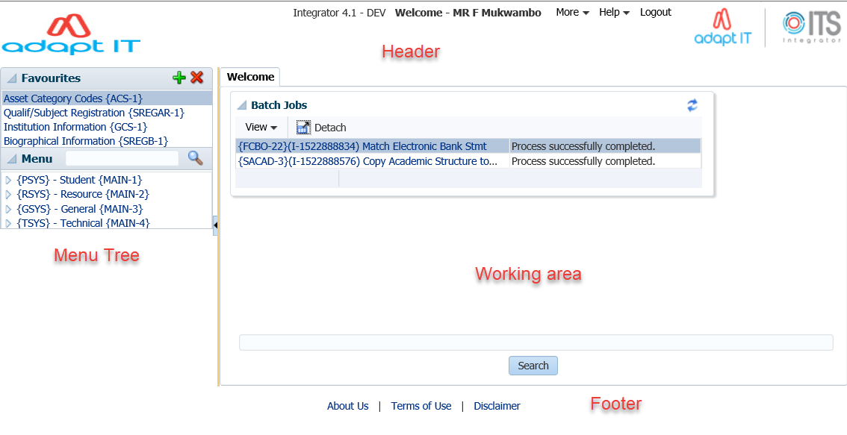

Integrator 4.1 requires that you use the mouse to move from one field to another. In previous versions, the user could navigate between fields using the Tab and Enter keys. However, the new

ADF technology operates in a browser and shortcut keys do not always give the intended output.

## Exiting a form

Use the Green door (old forms) or the black cross (new ADF forms) to exit forms programs in Integrator 4.1.



The Abort Option button is only for emergencies in the event of a menu option hanging.

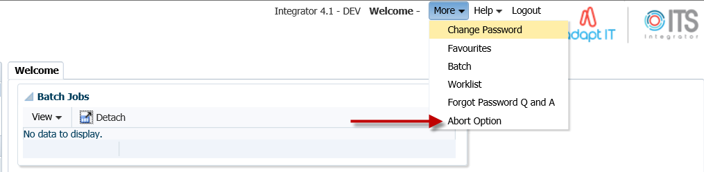

**MODULE 1**

# System Requirements

**Specific outcomes**

On completion of this module, you will be able to:

* Maintain account type definitions
* Maintain accounts receivable statement groups
* Maintain transaction type definitions
* Create new codes and update existing codes
* Link default statement groups to documents
* Update statement groups using document defaults

## Introduction

We are starting from the principle that the necessary cost centres {FCSO-1} and accounts {FCSO-3} have been defined and the necessary GLA’s {FCSO-6} have also been linked.

On completion of the set-up explained in this module, the following types of transactions can be processed in the AR system:

* Invoices, credit notes, journals, inter-debtor corrections, etc., can be created. Invoices can also be processed to be repeated at set intervals. In addition, invoices can be allocated to multiple GL accounts to allow for “distribution” of revenue.
* Invoices and credit notes which are issued manually, e.g. by departments on their own letterheads, can subsequently be recorded on this system by merely entering the transaction to the debtor’s account and the applicable transactions to the GL. Alternatively, the detail of the invoice or credit note can be entered into the system, and the document can be printed on letterhead stationery.
* Payments by debtors to the institution can be recorded in the counter subsystem, where the debtor account will be credited, the GL transactions will be generated and receipts issued. Payments, which are recorded by a non-ITS system and manually made out receipts, can be accommodated by either entering a receipt at a later stage or by a standard journal.
* Interest calculations can be done for debtors and staff debtors and their relation to the personnel and salary systems are catered for.
* Itemised debtor’s statements can be printed, which list the transactions and provide an age analysis of the outstanding balances.
* Income and control account transactions are created automatically, and control totals and audit reports are available.
* A facility is available to administer staff loans. Deductions can be made in the salary system and transferred to the debtor’s system.
* Functionality is available to control and monitor open item documents. The concept “Open Item” refers to the ability to match any relevant transaction to a specific source document. The client has the decision if this functionality will be used or not.

## Maintain Account Type Definition {FCSC-21}

Account types represent the control account in the ledger. This means that it is not an expense/income account. Account types allows you to break down the “account” in smaller manageable sections: thus, allows for better management information. An example would be to have an account type for sundry debtors per campus, or a control account for your rental debtors and your services debtors.

**See Example below {FCSC-21}**

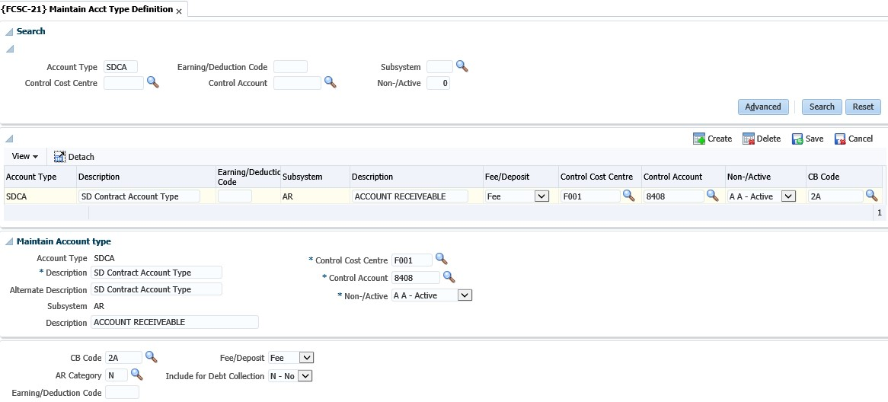

**Account type**: Enter a unique code for the account type.

**Description**: Enter a suitable name to describe the account type.

**Subsystem**: Enter the subsystem where this account type will be used.

**Fee/deposit**: This indicator is ONLY applicable if the subsystem is SD. The user needs to indicate if this account type is a (F)ee or (D)eposit account type.

Control GLA: This account type code is used in the specific subsystem but it will represent a GLA in the GL. Enter the CC and account for the account type.

**CB code**: When the subsystem is PM, the system wants to know from which CB the creditors will be paid. Supply the CB code where you will make the creditor payments.

**AR category**: This field is only applicable if the subsystem is AR. The debtor category is an ITS Integrator defined code and will indicate specific characteristics to be used in the AR system. For example, you can have staff loans, student loans, booking debtors or normal debtors. Enter the debtor category for the specific account type.

**Show Account Type**: This field is applicable for account types that are defined for the SD system and that will be used for contracts. Only if this field is marked as no, you can use it in the contract definition. All the standard SD account types will be set as yes.

**SD Statement Group Code**: This field is used with the SD statements where transactions are grouped and the details are not displayed on the statements.

## Maintain AR Statement Groups {FARC-4}

A statement group is a heading in the statement and all documents linked to the group that will print below the group heading. Statement Groups are mandatory for all AR documents. Integrator standard codes are provided with the install but clients may create their own Group Codes.

**See Example below {FARC-4}**

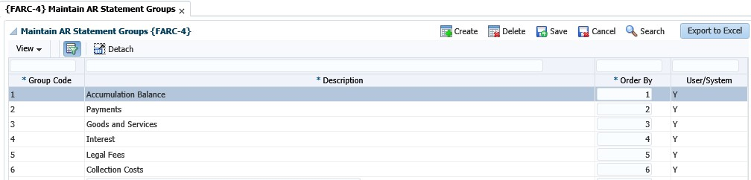

**Group Code**: A code to identify the Statement Group

**Description**: The description of the group code. This description, if used, will print as a heading in the debtor statement.

**Order By**: The order in which the group will be printed in the debtor statement.

## Maintain Transaction Type Definition {FCSO-7}

Transaction types can be seen as a “journal code”, such as registration fees, debit correction, etc. It is defined per subsystem and can only be a debit or a credit, except for the General Ledger and Expense budgeting subsystems. The basic characteristics and advantages of a transaction type are:

* It is specific for each subsystem
* A transaction type is either a debit or a credit transaction for the subsystem. (The GL transaction types are not applicable to this.)
* Where you have TT defined for specific type of transactions, mistakes in respect of GL allocations can be minimized.
* The process of automatic transactions is simplified
* Can make reporting easier where you are looking for type of “journals”, for example just class fees etc.

**Type**: Enter a unique code for your TT.

**Note**: It is recommended that you use number ranges for each subsystem. That way you know that all the CT transaction types are within the range 1000 to 1999 etc.



**Name**: Give a description of the transaction type. Remember that this should be done so that all users would know which transactions will be recorded against this code.

**Active Indicator**: Is the TT active or not? You will make use of this where you may have used a TT for specific purposes, but no longer want the users to use this. So, you query the code and make it non active. This means no user will be able to record transactions against this TT.

**Subsystem**: Enter the subsystem for which the transaction type is valid.

**Default value:** This field will be completed if the transaction type is usually for a specific value. This amount will default when used, but the users can still override the amount.

**Cashbook code**: This field is mandatory if the subsystem is CT and will indicate the cashbook code this TT is relevant to.

Where you have more than one cashbook, but you have the same type of transaction for multiple cashbooks you would create “duplicate” transaction types but indicate in the description for which CB code it will be used.



**Financial field**: This field will indicate what ‘type’ of transaction this TT will record. You have the following options:

* (S)-balance: this is where the system is calculating a brought forward balance.
* (B)udget: this will be for budget transactions as they are reported in different columns in the GL reports.
* (J)ournal: these are the ‘normal’ financial transactions and most of the transaction types will be linked to this field.
* (C)ommitment: these are for the PM system. An example would be where requisitions/order are created. The system will create a transaction in the commitment column of the GL reports.

**See Example below {FCSO-7}**

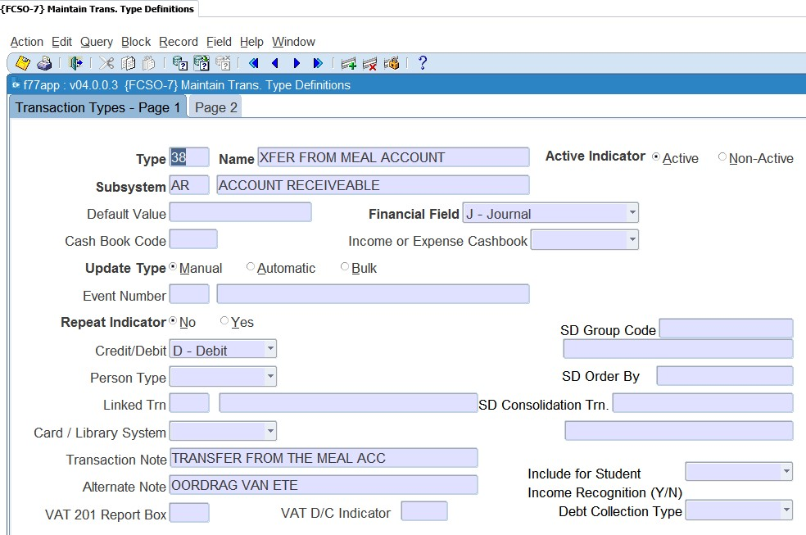

**Income / Expense**: This indicator is only relevant to the CT and CB systems. This is to differentiate between transactions affecting (I)income and (E)xpense on the cashbook.

**Update type**: This field can either be manual or automatic. Most of the TT definitions will be linked to manual. The automatic will be if the TT is linked to an event (see next field).

**Event Number**: This field will list all the predefined events. These events are defined by Adapt IT: Pretoria and you will ONLY link this to the relevant TT code. An event number will be “triggered” by specific programs to use TT automatic without a user selecting them. For the SD fees structure the system have the link between the TT and the events in the option {FSAM-29}.

**Repeat Indicator**: The user may specify repeating transactions in the Procurement Management (PM), Accounts Receivable (AR) and General Ledger (GL) Subsystems. Whenever the applicable screens are used, the system will control that a transaction type with a (Y)es in this field is used. The number of repetitions and the intervals will be specified, and the program will generate transactions accordingly. **Credit / debit**: What must happen to the debtor/creditor account? For example, if it is the SD system, should the student be debited or credited?

**Person type:** This can also be referred to as the debtor/creditor type. This field is applicable where the subsystem is CT or CB. The system wants to know, if this transaction takes place what other ‘subsystem’ must be affected. Remember that where the person type is student, it will also reflect on the students’ account, which means the SD system.

The ‘other’ person type is used where you have sundry transactions that are not for a debtor or creditor account.

**Linked transaction**: This field will be completed if this TT that you are busy defining can have VAT. The VAT portion will be recorded against the TT entered in this field.

**Card/Library system?**: If you are using the meals (card) or library system, then TT can be defined to receipt money in those specific ‘accounts’. The field will be used where the subsystem is CT. This field must be set to yes if you want to use it for those types of receipts.

**Transaction note**: This field is the note field that will default when the TT is used when a transaction is processed. Enter a note that will best describe the transaction to the debtor/creditor as this will display on their statements.

**Alternate note**: This field is the same as the transaction note field. This description will be used if you have indicated on the debtor/creditor biographical detail their preferred language is not ‘English’ but ‘Alternate’.

**VAT 201 box report**: This field is applicable if you are registered for VAT and do VAT reporting through the system. The box numbers with their information can be obtained from the receiver of revenue. **VAT D/C indicator**: This field is applicable if you are registered for VAT. It will be used to indicate if it is a debit or credit to the VAT transactions.

The following fields are all display fields and the detail is defined in the SD system*.*

* SD group code
* SD order by
* SD consolidation transaction
* Include for consumption report Y/N?

**See Example below {FCSO-7}**

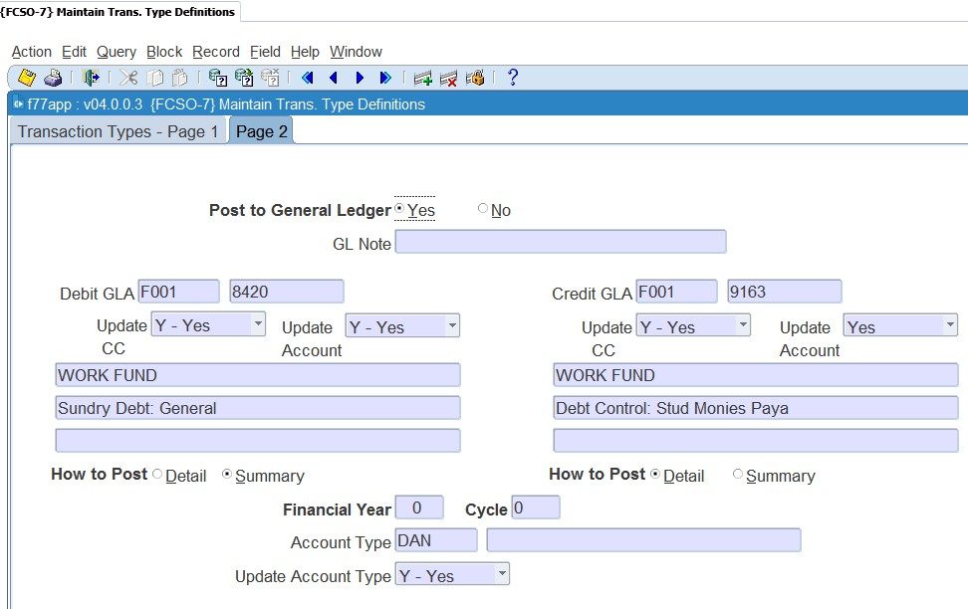

**Post to general ledger**: You will usually set this field to yes. This indicates if the transaction should be posted to the GL. This field is not applicable to the GL system as the transaction is already ‘in’ the GL system.

**Debit GLA**: Enter the GLA to be debited. This field will be completed if there is a specific GLA that must be used or where the GLA can’t be blank when automatic (TT linked to an event) transactions take place.

**Credit GLA**: Enter the GLA to be credited. This field will be completed if there is a specific GLA that must be used or where the GLA can’t be blank when automatic (TT linked to an event) transactions take place.

**Update CC**: Is the user allowed to change/update the CC? This field can only be set to NO if the “Update Type” field is set to (M)anual.

**Update Account**: Is the user allowed to change/update the account? This field can only be set to NO if the “Update Type” field is set to (M)anual

How to Post: Do you want to post the transactions in detail or summary to the GL? If set to summary, the system will accumulate all transactions (since the last posting) for the specific account which has not yet been posted, and post one transaction.

**Note**: It is recommended that you make the debit GLA indicator ‘summary’ for all debit transactions and the credit GLA indicator summary for all credit transactions. This will mean your GL reports are not that cluttered. Should you wish to see how the summary posting is made up you can request a report from the menu {FGLP}.



**Financial year**: This field is only relevant for TT linked to the GL system. This is where you wish to process transactions for a financial year that is different to the financial year of the system as indicated in {FCSM-2}. For all the other subsystems this field will have a value of zero, as the transactions will use the financial year as indicated in {FCSM-2} for the relevant subsystem.

**Financial cycle**: This is only valid for the GL system, for the rest of the subsystems set this value to "00". If a transaction type is meant to be valid only during a specific cycle, the user may enter a value equal to or greater than the present financial cycle, or in all other cases "00" (zero). If zero, the system will default to the cycle of the subsystem. Transaction Types linked to sub-system GL are subject to the setting of rule GH, of the system operational definitions, on menu option {[FCSM-1}](http://wlint4.adaptit.co.za:7221/itshelp/faces/helppages/config.OHW+Servlet+1/vtAnchor.Block_2/topics/navSetId.itshelp/itshelp/documents/fcsm-1.html#Block_2), TAB - System Operation Definitions.

* Rule [GH](http://wlint4.adaptit.co.za:7221/itshelp/faces/helppages/config.OHW+Servlet+1/vtAnchor.GH/topics/navSetId.itshelp/itshelp/documents/fcsm-1.html#GH) provides the facility to prevent the update of the financial year and cycle for Ledger journals. Whenever the user supplies a transaction type on any of the GL journal screens, may the user update the financial year and cycle, (Y)es or (N)o? This rule must also be read in conjunction with rules GC and GY.
* Rule [GC](http://wlint4.adaptit.co.za:7221/itshelp/faces/helppages/config.OHW+Servlet+1/vtAnchor.GC/topics/navSetId.itshelp/itshelp/documents/fcsm-1.html#GC) provides the facility to allow Ledger journals to be processed in previous cycles and rule GY provides the facility to allow Ledger journals to be processed in previous years.

**Account Type**: Supply the default Account Type to be used. This is not a mandatory field. A <LIST> function is available and where the subsystem, is AR, the <LIST> function will only contain active Accounts Types defined for AR.

**Update Account Type**: Can the User update the Account Type (Y)es/(N)o. When this Transaction Type is used, may the user update the Account Type?

## Maintain System Operational Definitions {FCSM-1}

The system operational parameters are all pre-defined codes and cannot be removed or changed by the user. The user can only decide how the specific rule should be applied to the system.

**See Example below {FCSM-1}**

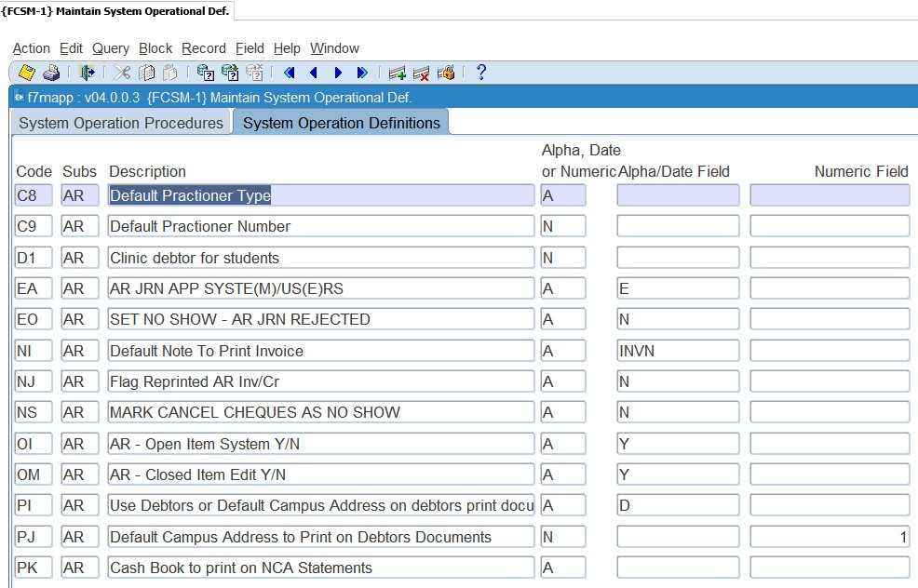

**EA**: AR journal approval by syste(M) or us(E)r

If you make use of electronic document approval the parameter should be set as us(E)r. If not it means that all transactions that are recorded on the AR system has been approved manually.

**EO**: Set no show when AR journal rejected Y/N

This parameter is used in conjunction with ‘EA’. If you have indicated that users need to approve the AR document/transactions and this code is set to (Y)es:

* The system will set the rejected transaction and its contra transaction to 'no-show' {FARO-11} and it will not print on statements.
* The AR statement program {FAROR1-3} will not print transactions set to 'no-show’.

**NI:** Default note to print on the invoice

Should you wish to add a note when printing an invoice, you can set up a ‘letter’ code in {FDCO-1} and the text linked to the code will print at the bottom of the invoice if ‘add default note to document’ is Yes when you run {FAROR1-1}.

**NJ:** Flag reprinted AR invoice/credit note

The valid values are (Y)es or (N)o. Where you set the value to (Y)es you will be able to print the invoice/credit note as often as you like and the printout will ‘look’ the same. If you set the value to (N)o the words “Copy Only” will be printed on all invoices {FAROR1-1} or credit notes {FAROR1-2} when reprinted.

**NS:** Mark cancelled cheques as no-show

Valid values are (Y)es or (N)o. If ‘Y’es, the system will mark the payment and the cancellation with a now-show indicator to not print when generating a statement for the debtor.

**OI:** Open Item system in use

Are you making use of the facility to allocate credit transactions to specific debits?

**OM:** Closed item edit Y/N

Do you allow the users to remove the link between debits and credits?

**PI:** Use Debtors or Default Campus Address on debtors print documents

Values are C/D (Campus/Debtor). The parameter indicates the campus to be used to derive the address to be printed on an AR Debtor Statement using option {FAROR1-12} as he the Institutions Physical and Postal Address. If Debtor, the campus address of the campus linked to the debtor (person) is used, else the campus address or the default campus linked to system operational parameter PJ is used.

**PJ:** Default Campus Address to Print on Debtors Documents

Must be a valid Campus Code from option {SPCS-1}. If System Operational Parameter PI of subsystem AR is set to Campus, then this campus address will be used as the Institution Physical and/or Postal Address. <List of Values> is available.

**PK:** Cashbook to print on NCA Statements

Must be a valid Cashbook Code from option {FCSC-5}. The banking information printed on an AR Debtor Statement is derived from the Cashbook Code entered. The program Debtor Statement, option {FAROR1-12}, gets the Bank Name, Branch Code and Account Number tags from the cashbook linked here. <List of Values> is available.

**PP:** AR Statement Number Sequentially per Debtor or Unique Statement Numbers

If set to unique statement numbers, the system operational definition code 'S2' for subsystem 'SD' must also be considered. If both, 'S2' and 'PP' are set to unique statement numbers, a unique statement number will be allocated throughout the two systems whenever a statement is generated. No two statements will have the same number, but statement numbers for a debtor, SD and AR, will also not follow on each other. If either one is set to generate unique statement numbers, only statement numbers in that system will be unique. Statement numbers for the other will follow sequentially one after the other per debtor.

**Note**: Remember that where you allow this it means that if a statement has been generated and changes are made after that you will not be able to “reproduce” the statement.



## Link Default Statement Groups to Documents {FARM-3}

It is mandatory that each AR Document must be link to a Statement Group. To assist the user, this menu option defined the default statement group for each Type of Document in AR. When the user creates a document, the system will default this definition and in some cases the user is allowed to change it to a different statement group, if required. The following combination will be installed:

**See Example below {FARM-3}**

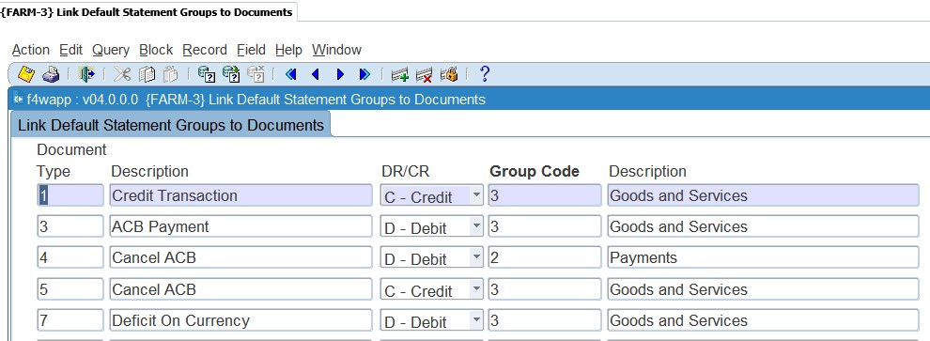

**Type**: A unique character as allocated by Integrator for the different AR Documents.

**Description**: Description of the Document.

**Debit/Credit**: The debit or credit indicator of this Type of Document.

**Group Code**: The default statement group code linked to the document type a defined in option {FARC-4}. A <List of Values> is available.

**Description**: The description of the statement group code.

If the client created their own statement groups, link them to the required Type of Documents if applicable and updateable and you may update these changes to your current year Debtor Document not linked to a statement number using option {FININS-1}.

## Update Statement Groups Using Document Defaults {FININS-1}

If the user change the Integrator install statement group codes on option {FARM-3} and need to apply the changes to AR documents that were not printed on/linked to a statement number, then this option will do those updates.

**See Example below {FINNIS-1}**



**MODULE 2**

# Notes

**Specific outcomes**

On completion of this module, you will be able to:

* Create a note.
* Set-up note reminders.
* Send manual and automatic emails.

## Introduction

Users do not have automatic access to “notes” that were created. Access must be given to users to access notes and they can be restricted to only view, add, query and view existing notes. This will be done in the user restriction option for the specific subsystem. An example is {AMNT-8} for assets, {SMNT-5} for students, {FCSM-4} for finance and {PAMT-1} for personnel etc.

Notes can also be used if there is a need to make notes to specific qualification or subject information. If the user did not have any notes training before, we suggest the user attend this training or the super users to set up these applications. The user can also refer to the Notes training document if more information is needed.

## Creating a Note

Proceed to the applicable option where you would like to use the functionality of adding a note, for example: {FARO-21}. You can query any debtor in this option and type general notes in the Notes panel box. Type-in the note and save.

**See Example below {FARO-21}**

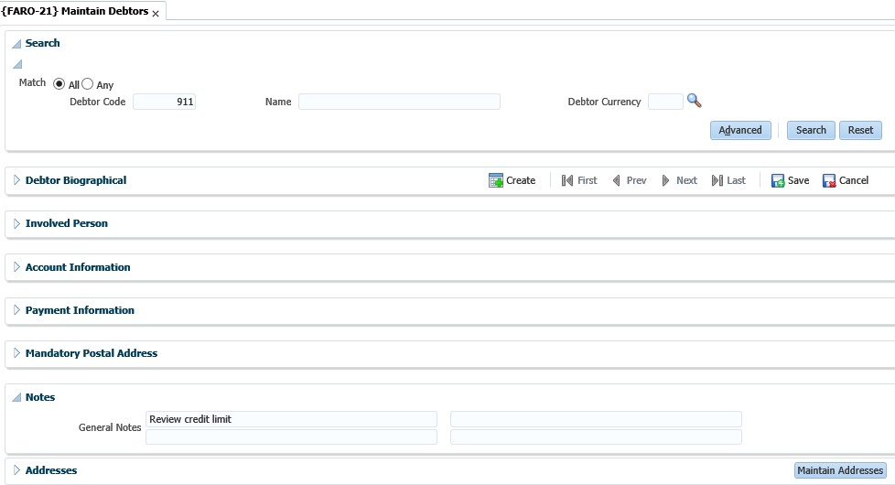

## Send Notes Reminder Mail {GOPS-23}

This is a report a user can run at any time to start the e-mailing process for certain selection criteria.

**See Example below {GOPS-23}**

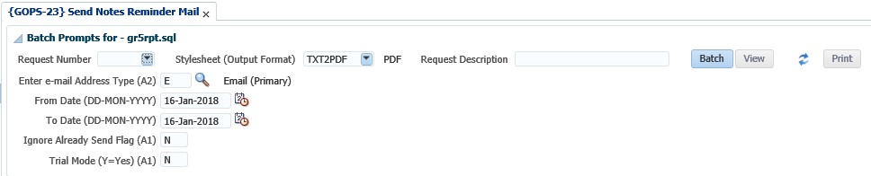

The LOV on the e-mail address type will list only address types where the type is defined as a type email. The mail will be sent to this selected e-mail address, if this address is specified for the personnel. If the mail address type does not exist for a person, the mail will not be sent. All mail where the date/time of the reminder fall between the 'From Date' and 'To Date' will be selected.

If the user selects trial mode = ‘Y’es, only a report will be produced to list all the possible e-mail reminders that will be send, but the actual mail will not be send. When specifying the trial mode as ‘N’o, a report will be produced and the e-mail will be send.

**See Example below**

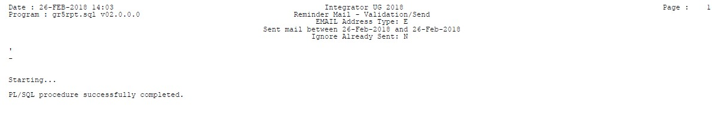

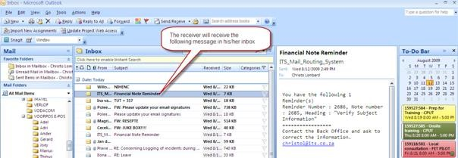

Once the mail reminder is sent to the selected user, the reminder note will be marked as sent.

**See Example below {FCTO-10}**

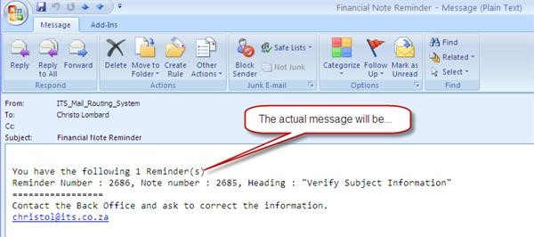

## Background Processes {BATCH-9}

This option will send notes reminder e-mail every **X** minutes automatically for a specific date as specified by the user. Go down to the 'gen.gr5pkg. Send_Reminder*;'* procedure. Specify the 'Interval' in minutes when the mail must be sent. Change the 'Status' to Running.

**See Example below {BATCH-9}**

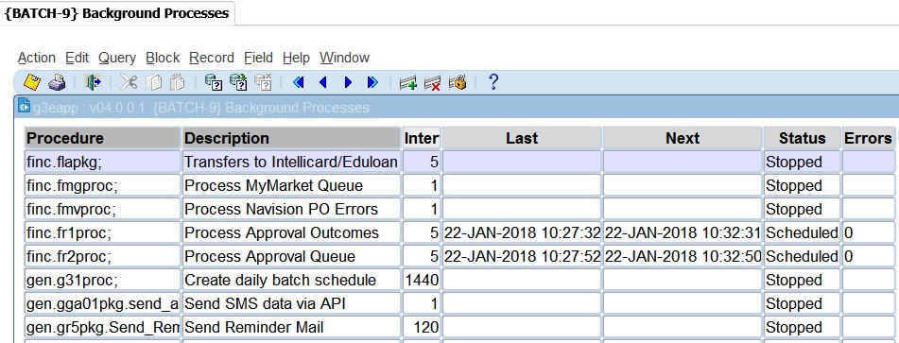

This option will send all reminder notes for system date to the selected users. It will automatically send to the person's primary active e-mail address. Once the mail was successfully sent, the reminder note will be marked as per the above manual option.

**MODULE**

**3**

# Accounts Receivable Transactions MPM {FARO-14}

**Specific outcomes**

On completion of this module, you will be able to:

* Create invoices and credit notes.
* Duplicate invoices.
* Print / mail invoices and credit notes.
* Cancel invoices.
* Maintain no show indicators.

## Introduction

This is Multi Process Management (MPM) for accounts receivable. The aim of an MPM is to empower the user to work with an entity (in this case, a debtor) using only one menu option. This will provide a 360-degree view of the debtor, the transactions linked to the debtor, details of the transactions, as well as allow the user to create new transactions or edit existing ones. If no debtor is searched for in the 'Debtor Details' panel box, the options listed in the 'Tasks" panel box will either open with no details prefilled (Invoice, Credit Note, Maintain No Shows) or will not open at all (Maintain GLA, Copy Invoice, Cancel Invoice).

**See Example below {FARO-14}**

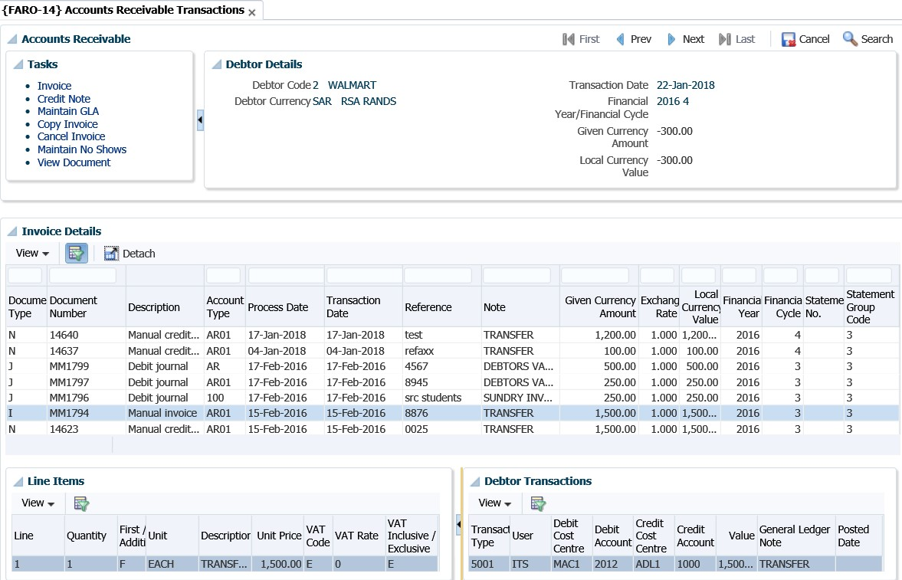

## Process Debtor Transactions {FARO-1}

This is the option where you will process invoices for a debtor. The option allows you to also print the invoice after processing it. This option is also used to process other “types” of debit and credit transactions for a debtor. When you access the option a list of available transactions will be displayed according to the sequence in {FCSO-23}. The user must highlight the specific process that he/she would like to do. Once you have selected the type of document you would like to process there is an additional functionality that will allow you to copy data (detail) from a previous document. That means you can copy detail instead of retyping everything.

This option is made up of 3 panel boxes, 'Search', 'Debtor Account Type Balances' and 'Debtor Transactions' and is used for the following:

* Creating an Invoice
* Creating a Credit Note
* Maintaining the GLAs of an unposted Invoice or Credit Note
* Creating a Copy of an existing Invoice or Credit Note

When you search for a debtor in {FARO-1}, the following screen displays, and you can choose to either “Create Invoice” or Create Credit Note”.

**See Example below {FARO-1}**

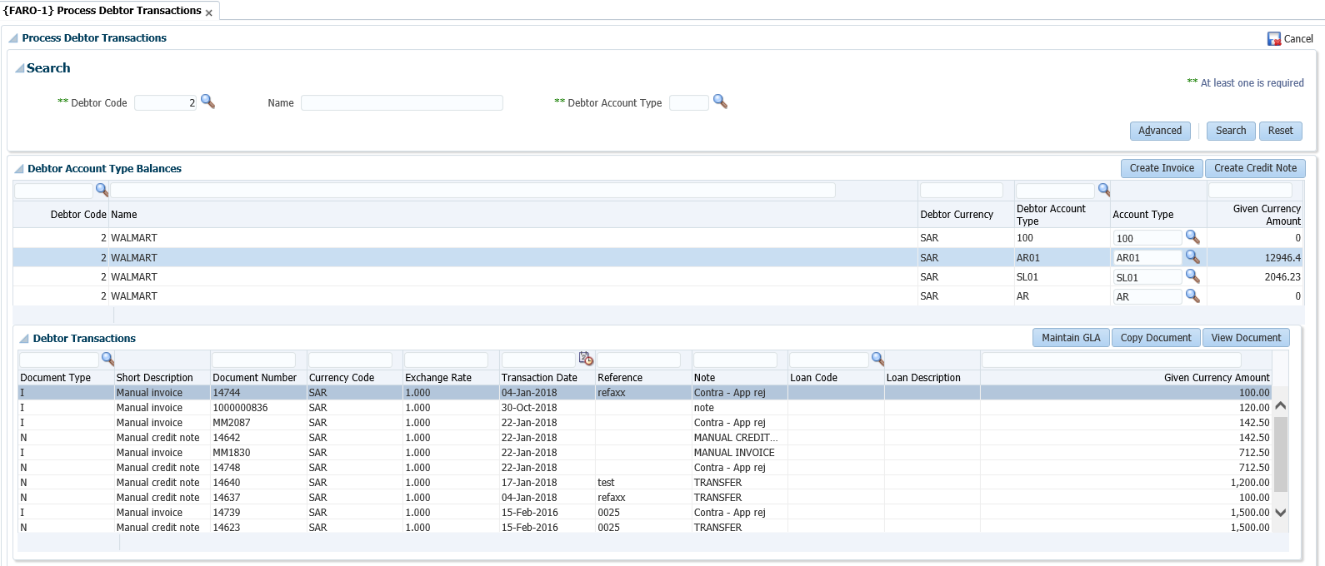

### Create Invoice

**See Example below {FARO-1}**

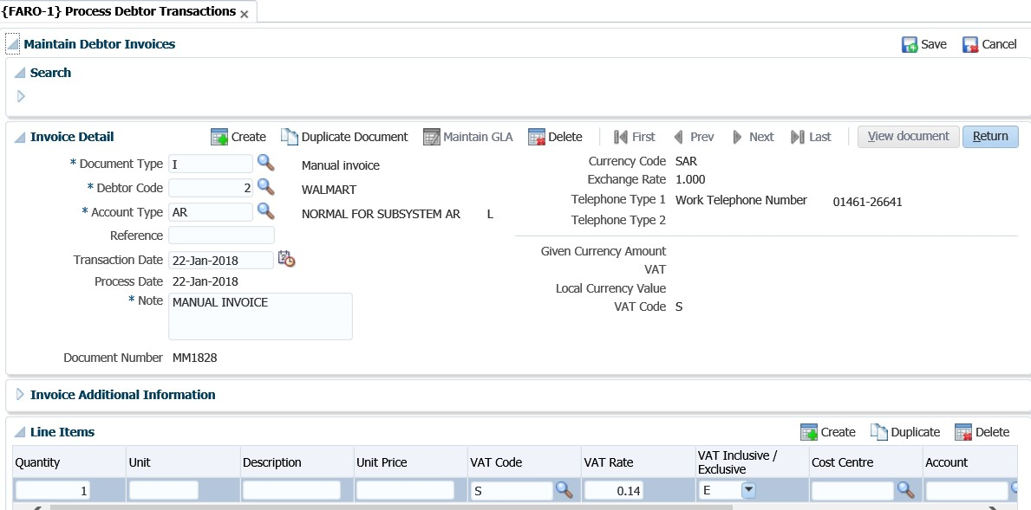

**You can also utilise the Accounts Receivable EP.**

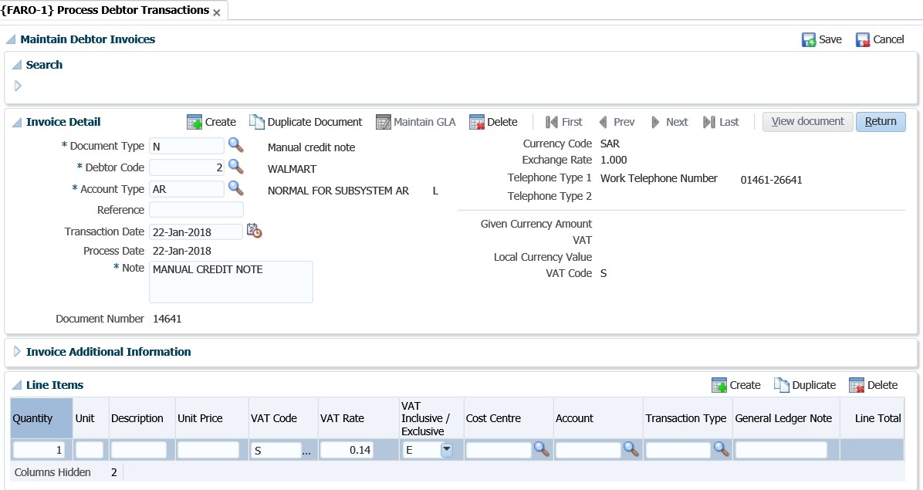

**See Example below {FARO-14}**

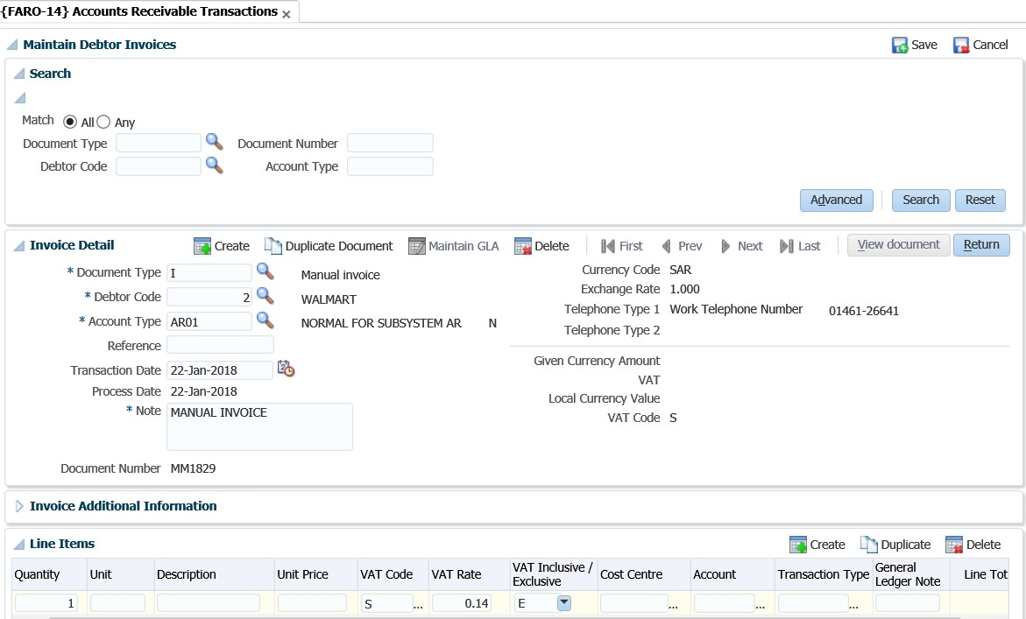

**See Example below {FARO-14}**

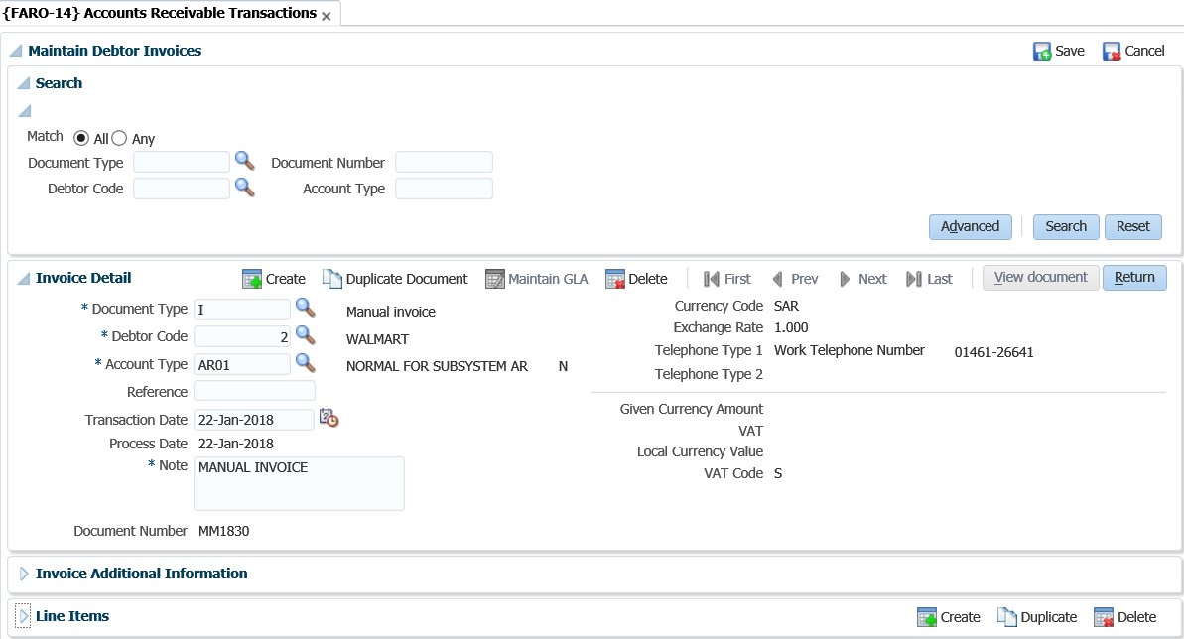

The user can enter the 'Debtor Code', 'Name' and/or 'Account Type' and click on the 'Search' button to view existing transactions for the 'Debtor Code', 'Name' and/or 'Account Type' combination. If the search functionality is used, then all processes thereafter will default with the search criteria.

**Panel box 2: Invoice Detail**

**Document Type**: This field will default to an 'I' when the user clicks on the 'Create Invoice' button and an 'N' when the user clicks on the 'Create Credit Note' button.

**Debtor:** The debtor code against which the document is to be processed. Will default to the debtor that was searched for in the search panel. If no debtor was selected, then the user will have to type in a debtor code or select a debtor by clicking on the <LIST> command.

##### Account Type: The 'Account Type' will default to the account type for the line that was selected in the 'Debtor Account Type Balances' panel box. The user can select a different account type by clicking on the <LIST> command. This will list all the account types for the ‘AR’ system, as defined on {FCSC-21}. Reference: An optional first documentation support reference, e.g. reference to an Order Number, Invoice, Credit Note or another Journal. This reference number is more meaningful for credit notes and/or payments.

##### Transaction Date: The date that should appear on the transaction. System date is used as the default date. This date must be greater than the last statement number's statement date.

##### Process Date: This is the date on which the transaction was processed i.e. the system date.

##### Note: This will default from the description of the document type, however, the user can type in their own note.

##### Document Number: A system generated unique number for this document that is maintained on {FCSM-3}.

##### Currency Code: This is a display field only and cannot be updated by the user. The currency code will default from the debtor detail as set up in {FARO-21}.

##### Exchange Rate: This value will default from {FCSO-21} for the given currency as in the Currency Code Field above. This field can only be updated if the indicator for subsystem ‘AR’ is set to (Y)es in option {FCSO-21}. Also refer to the Code Structure manual for a complete explanation of option {FCSO-21}. Telephone Type 1: This is a display only field and will default from the 'Telephone Type 1' field in the 'Invoice Additional Information' panel box.

##### Telephone Type 2: This is a display only field and will default from the 'Telephone Type 2' field in the 'Invoice Additional Information' panel box.

##### Given Currency Amount: Displays the value of the document in the debtor’s currency.

**VAT:** Displays the VAT for the document.

**Local Currency Value**: Displays the value of the document in Local Currency. The value is obtained by multiplying the Given Currency value with the exchange rate.

**Panel box 3: Invoice Additional Information**

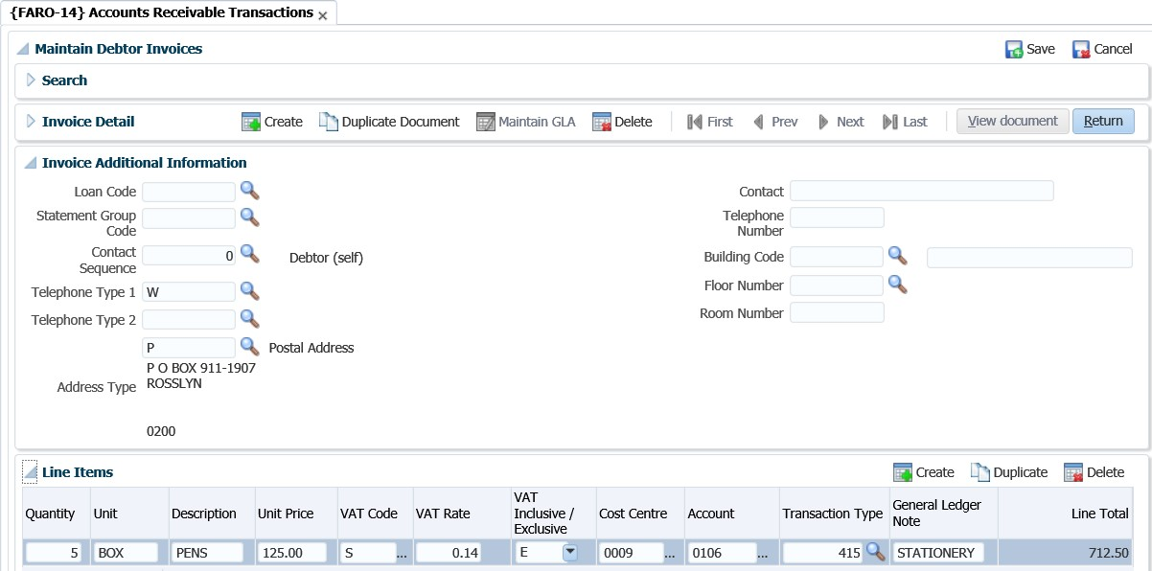

**Loan Code**: This field is not mandatory but allows the user to enter a loan code if an adjustment is to be made to a Staff loan or Student loan. The user will only be able to access this field if the account type used in Account Type on the document is linked to a category of S or L on the account type definition {FCSC-21}. The link between the loan and account type can be found on {FARS-1}. The staff loan will be updated when the user commits the document.

**Statement Group Code**: Statement Group Codes is defined in option {FARC-4} and linked to AR Document Types in option {FARM-3}. Statement Group is only updateable if the Statement Number is null. The system will default the Group Code linked to the document as defined in option {FARM-3} and if is updateable, then the user may change it on this screen. The group code is updateable until a statement number is linked to the document.

**Contact Sequence**: This number is used for identifying the addresses and/or telephone detail for the contact in question. Contact sequence = '0' always refers to the debtor himself - Primary contact. This field is mandatory for documents that must printed. The document types referred to are Invoices (Normal or Repeating) and Credit Notes (Normal or Repeating).

**Telephone Type 1**: Telephone number for contact in the Contact Sequence field as above. A list of valid types is available.

**Telephone Type 2**: Telephone number for contact in the Contact Sequence field as above. A list of valid types is available.

**Address Type**: Address type for contact sequence referred to in the above Contact Sequence Field. A list of valid address types is available. This field is mandatory for documents that must be printed.

**Contact**: The name of the person who requested the document.

**Telephone Number**: The contact person’s telephone number.

**Building Code**: The code of the building in which the contact person resides. If the building is in the Space Inventory, its name will be displayed. The <LIST> command will show valid building codes. If the building is not in the space inventory, this field may be left blank and the building name entered in the following field.

**Floor Number**: The floor number of the contact person.

**Room Number**: The room number of the contact person. (Refer to Space Inventory {SPOPS-1} for information regarding the room-numbering convention).

**Panel box 4: Line Items**

**Quantity:** The number of units that have been supplied.

**Unit:** An eight-character descriptor, e.g. Unit, Kg, Litre, etc.

**Description**: Description of the item.

**Unit Price**: The unit price in the debtors’ currency. Unit price must be entered exclusive of VAT as VAT will be added by the program if a VAT rate with a value greater than 0.00 is entered on the line. **VAT Code**: Is VAT payable on this item? Reply with an existing VAT code as defined in option {FCSC-1} and the system will display the value in the “VAT RATE” field. The system will use the VAT rate to calculate the total at the top of the "Transaction Detail tab. The user will have to link a default VAT code to SOD 'VA' in {FCSM-1}.

**VAT Rate**: The VAT rate that should be applied to the line. Selecting the VAT code on the VAT field will default the rate linked to the VAT code. For further details regarding this field, see VAT.

**VAT Inclusive/Exclusive**: If VAT is Inclusive (i.e. The VAT is part of the 'Unit Price'), then the system will calculate the VAT amount by deducting the VAT from the 'Unit Price'. If the VAT is Exclusive (i.e. The 'Unit Price' does not have any VAT added to it), the system will add the VAT by calculating it from the 'Unit Price'.

**Cost Centre**: Invoice - The cost centre for the credit leg of the transaction

Credit Note - The cost centre for the debit leg of the transaction

**Account**: Invoice - The account for the credit leg of the transaction

Credit Note - The account for the debit leg of the transaction

**Transaction Type**: Supply a valid, appropriate transaction type code, as defined in option {FCSO-7}. The transaction type codes are to a certain extent, restricted per screen. However, it is still possible to make mistakes and users should be careful in defining transaction types: staff should be thoroughly trained and aware of the dangers of using incorrect types. The system will however validate that the Dr/Ct indicator on the type of document is the same as that on the transaction type. Events 'VC' (Invoices) and 'VD' (Credit Note) were created to default the transaction type of the transaction if the user leaves the transaction type field blank. The system will control that a VAT transaction (“linked”) is used if a non-zero VAT rate was used. The test is executed only when the credit GLA is entered. If not, the system will respond with: “VAT linked transaction is required for transaction with non-zero VAT value”

**General Ledger Note**: An optional note to accompany the transaction. On entering the transaction type, the system will insert the short name of the debtor and the reference number as specified on the Document. The user is allowed to update these values.

**Create button**

A new line to enter the Financial Item Detail is created.

**See Example below {FARO-14}**

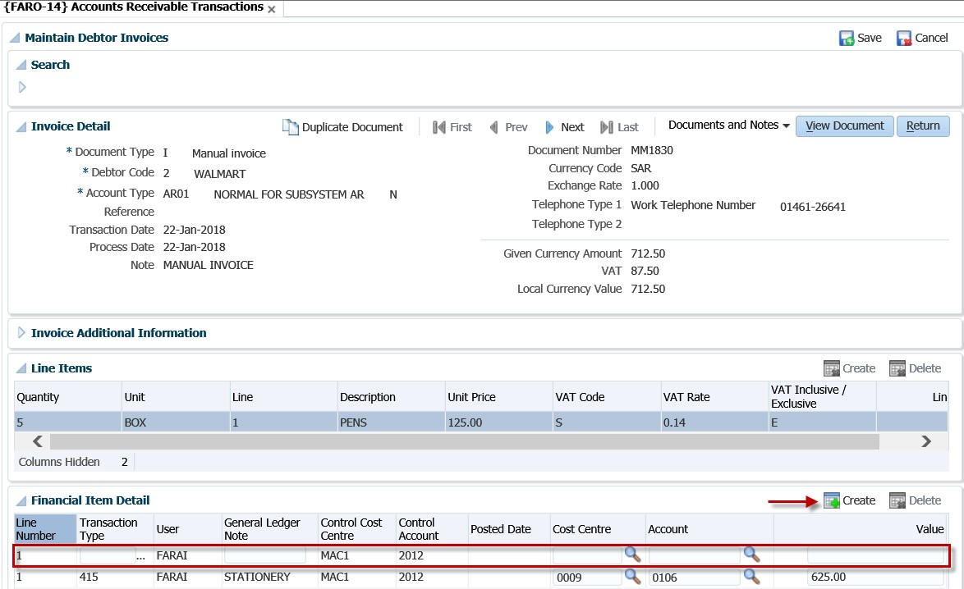

**Save button**

The invoice is created when you click on the “Save” button.

**See Example below {FARO-14}**

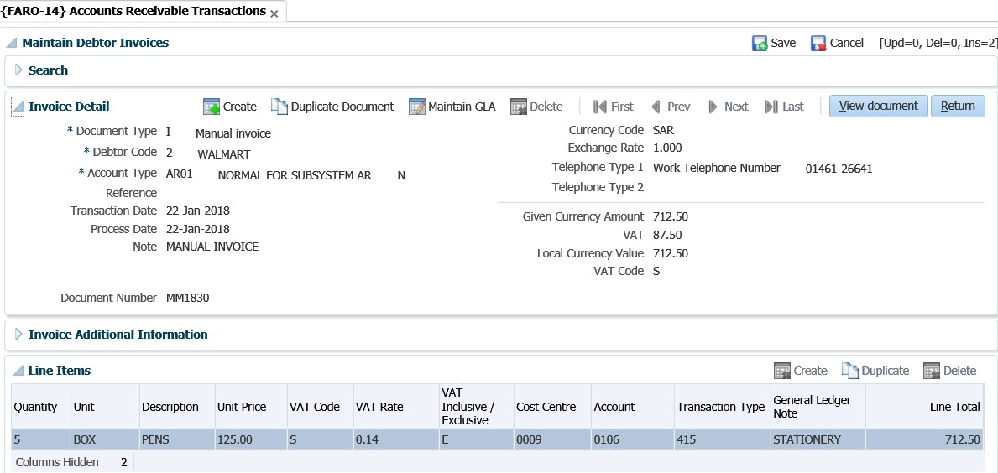

**View Document button**

By clicking on the 'View Document' button, the option will open the Invoice or Credit Note as well as the batch prompter. The batch prompter will enable the user to view, mail or print the document.

**See Example below {FARO-14}**



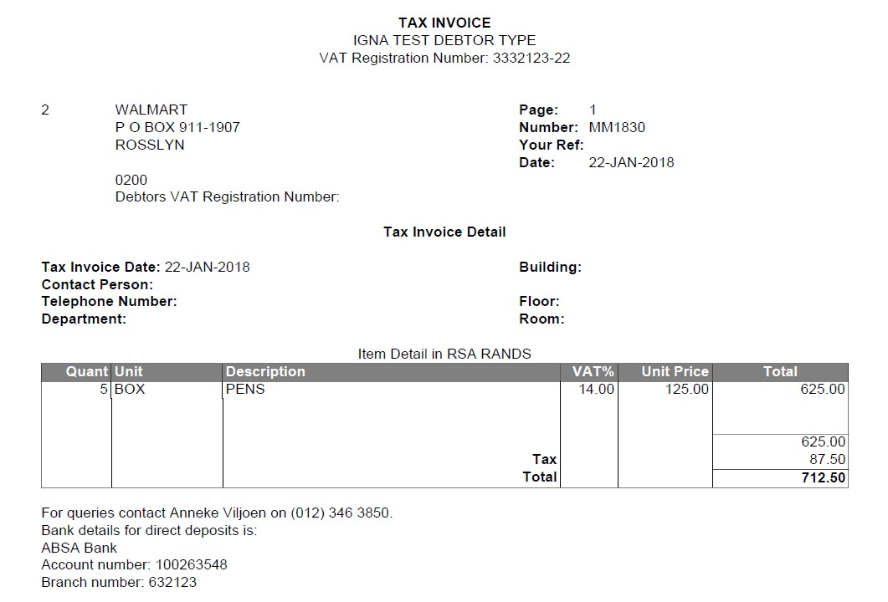

**Duplicate Document**

Allows the user to copy the details of an existing invoice. By clicking on the 'Copy Invoice' button, the system will create a duplicate of the invoice selected, but with a different invoice number. The fields that are updateable are the same fields as when the user creates a new invoice, except for the invoice number field.

**See Example below {FARO-14}**

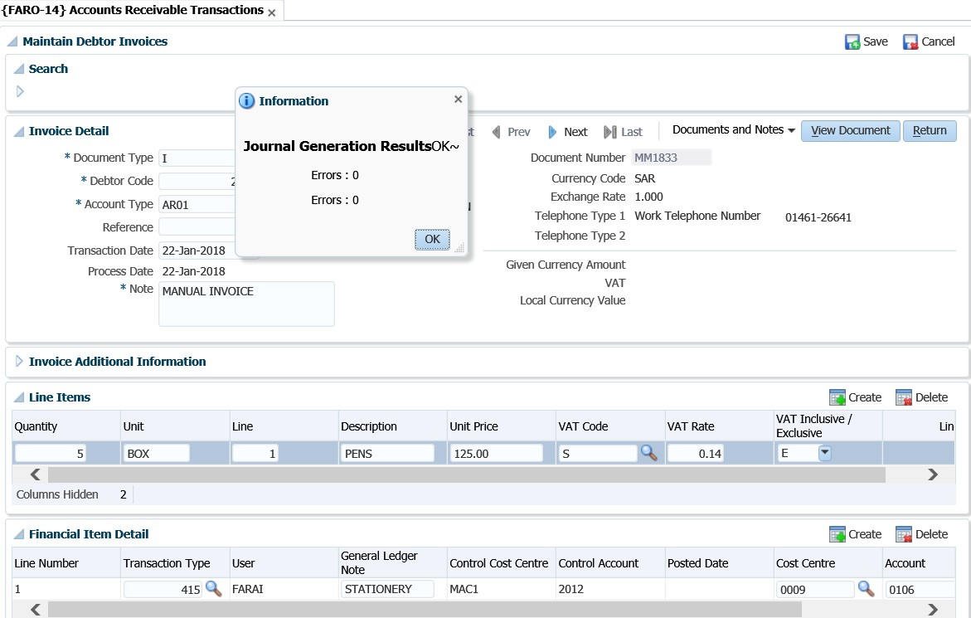

**Maintain GLA**

**See Example below**

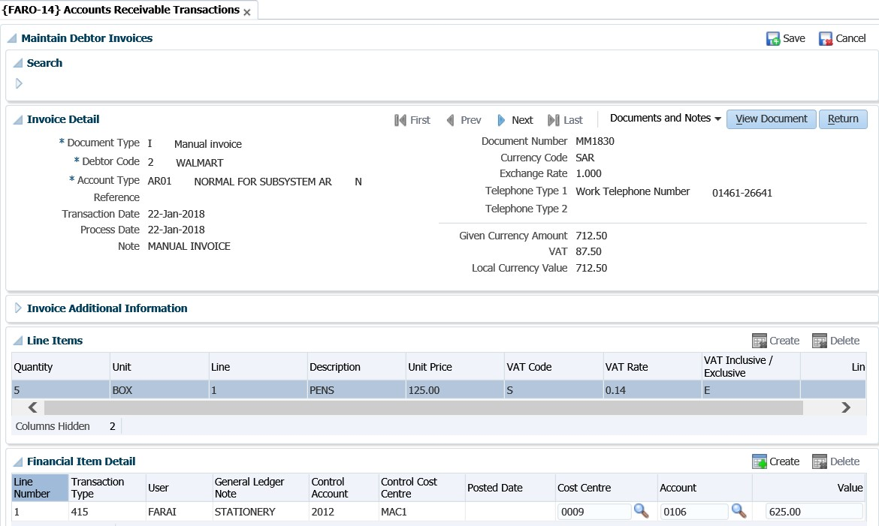

The user can maintain the GLA of a debtor transaction with this task. The GLA can only be changed if the transaction has not yet been posted to the General Ledger.

**Documents and Notes LoV**

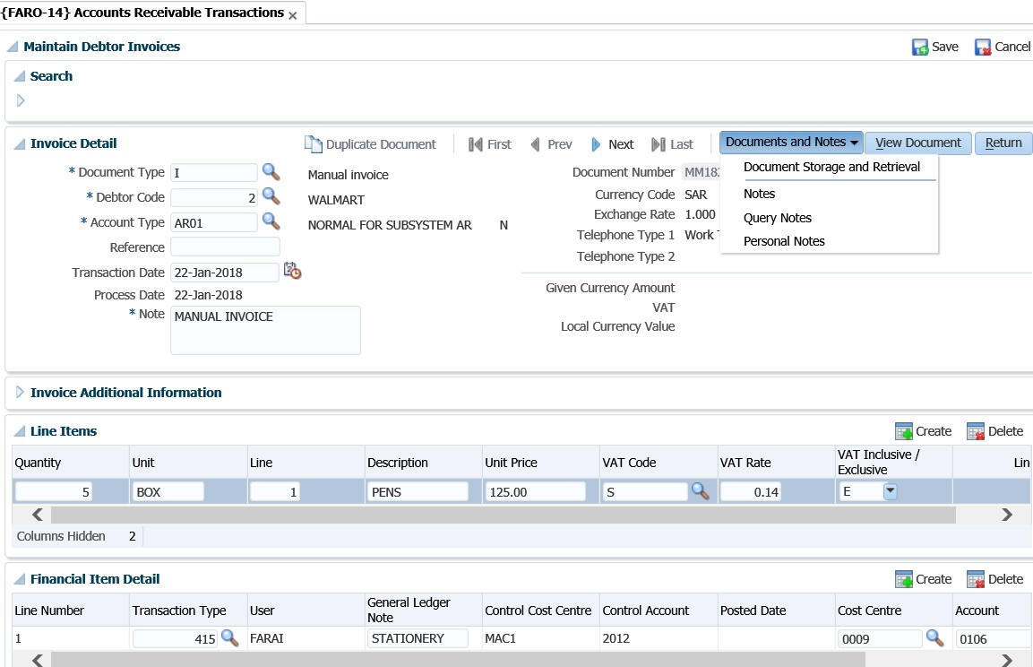

(Refer to the information on “Invoice” for a detailed explanation of the fields)

**Save button**



**See Example below**

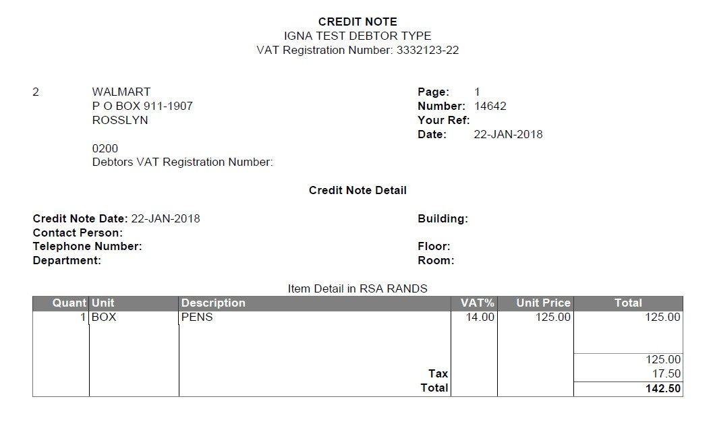

**See Example below {FARO-14}**

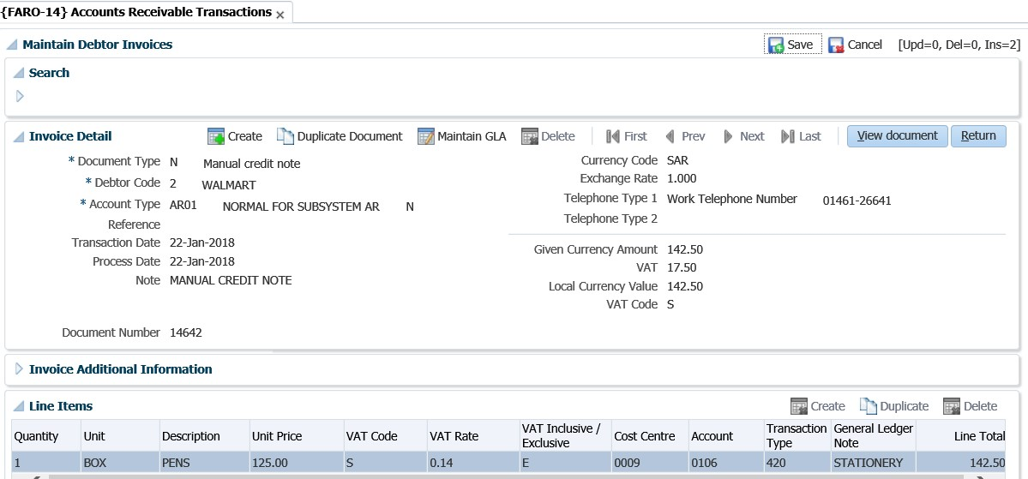

**Duplicate Document**

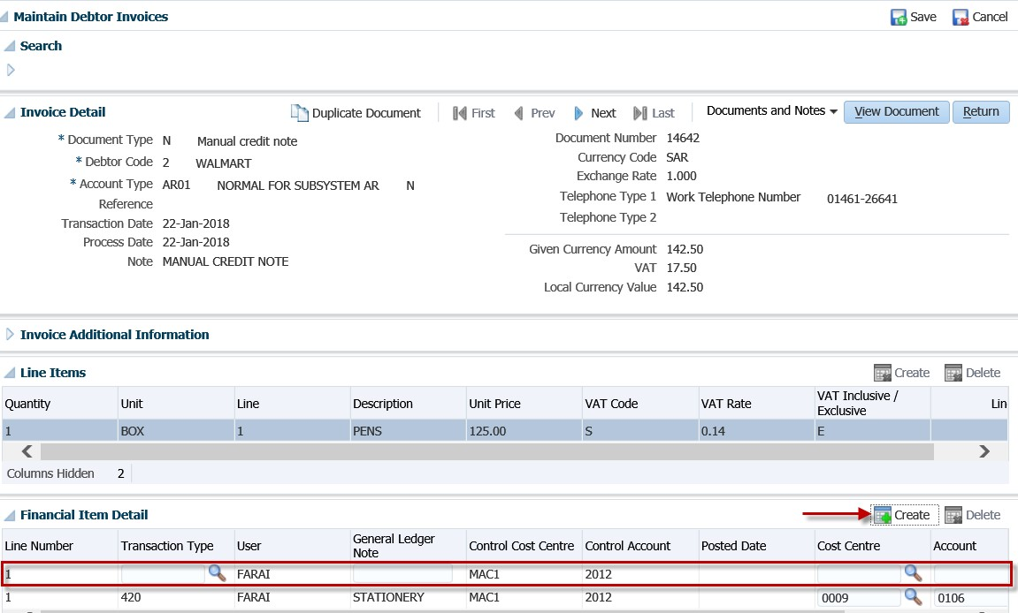

**Copy Invoice**

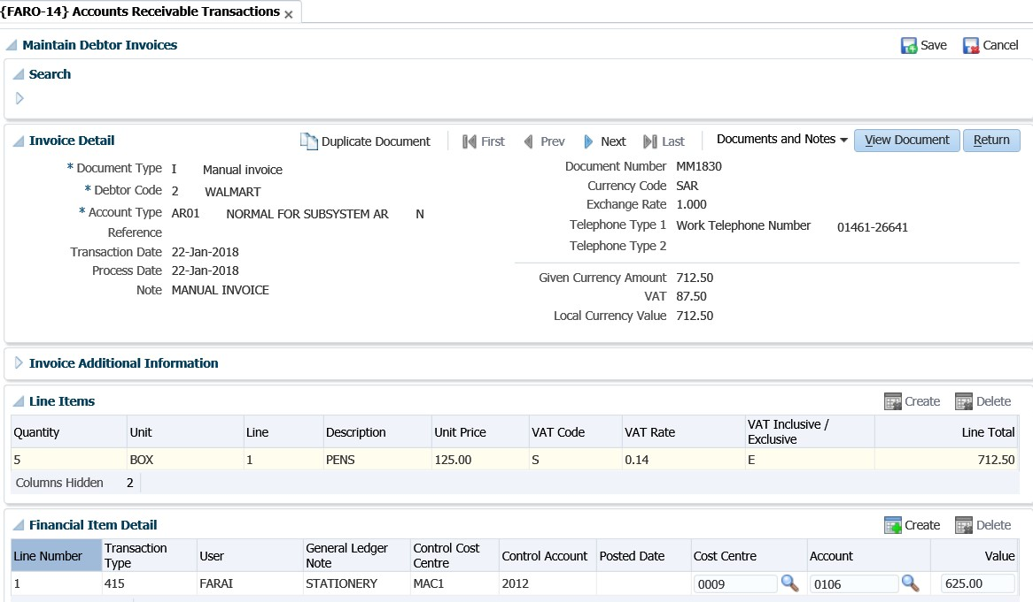

## Cancel Invoice {FARO-5}

Allows the user to cancel single or repeating invoices.

**See Example below {FARO-14}**

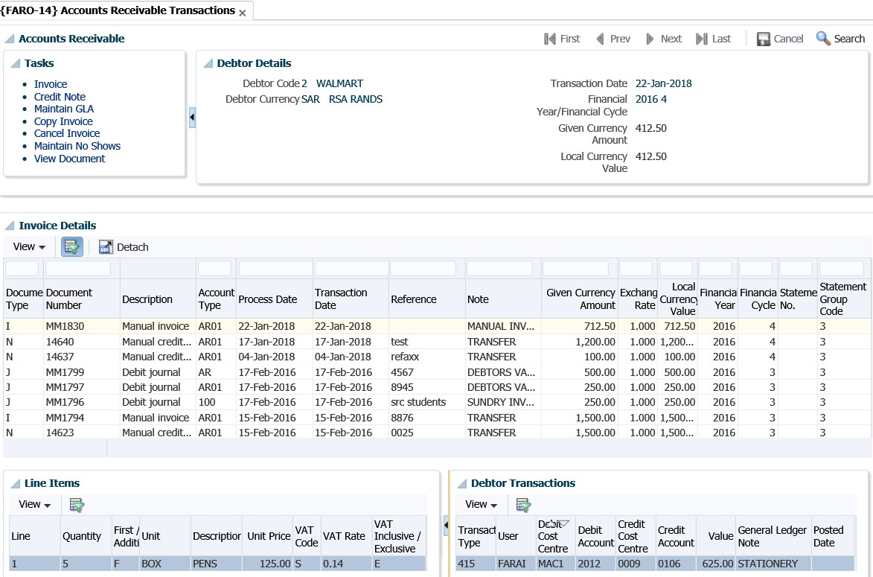

Allows the user to suppress the printing of contra entries on a specific debtor’s statement for a specific account type. This could be useful for suppressing multiple erroneous entries that crowd the statement.

**See Example below {FARO-14}**

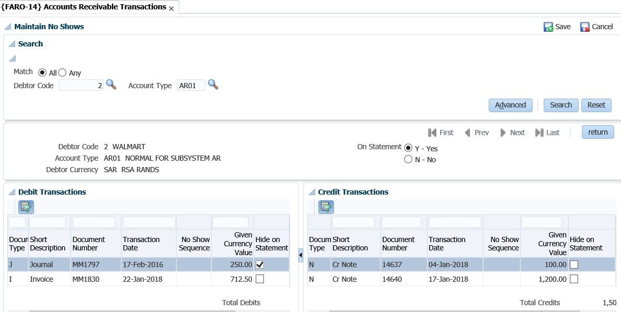

Transactions for an account type are displayed and only the 'Show on Statement' indicator can be updated. A blank field means that the item will be printed.

**MODULE**

**4**

# Other Operational Menus

**Specific outcomes**

On completion of this module, you will be able to:

* Maintain debtors.
* Query types of documents.
* Default text on multiple invoices.
* Query debtor transactions.
* Calculate interest on debtor balances.

## Introduction

Debtors may be divided into two groups, namely student debtors and other debtors such as central government, sponsors, personnel and organisations from commerce who use the facilities and/or expertise of academics. Student debtors are fully catered for within the student accounts subsystem (refer user manual for student debtors), whereas this module allows for keeping record of the other debtors.

## Debtor definition pre-requisites

**Step 1**: Account types must be defined for the AR subsystem in {FCSC-21} and linked to the relevant debtor categories (see next step for available categories).

**See Example below {FCSC-21}**

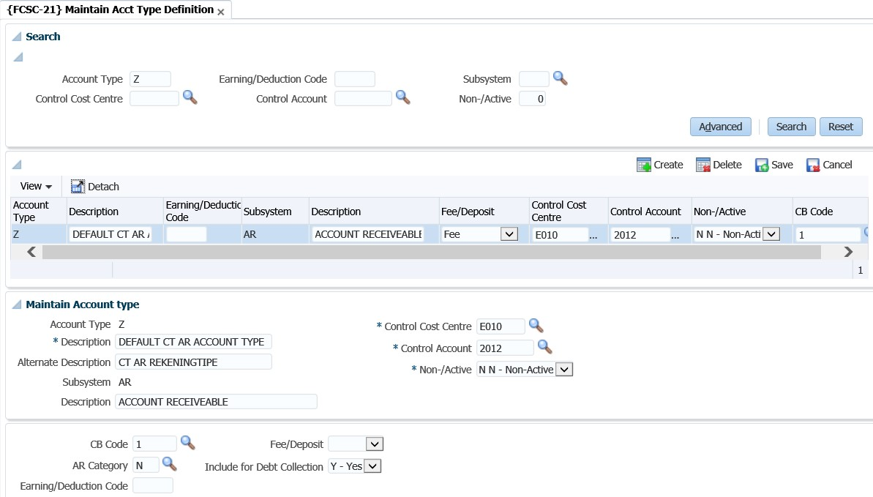

**Step 2:** The debtor categories are pre-defined and cannot be changed. The debtor category will determine the use of the specific account type for a type of transaction. Decide what type of sundry debtors will be maintained in the system so that the right account types can be created. The different types of sundry debtor transactions are, (N) normal transactions, (S) staff loans, (H) clinic system, (L) student loans, (C) contact debtor or (B) booking transactions.

**Step 3:** Create at least one debtor type in {FARC-1}. This debtor type will be linked to the debtor on the debtor definition. Reports can be requested per debtor type.

**See Example below {FARC-1}**

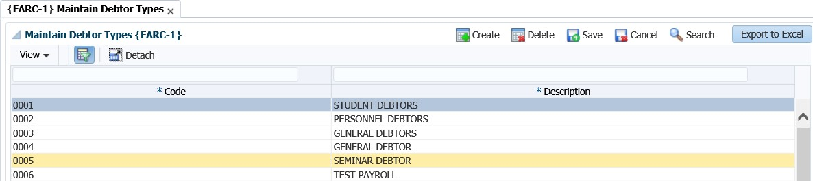

**See Example below {FCSC-21}**

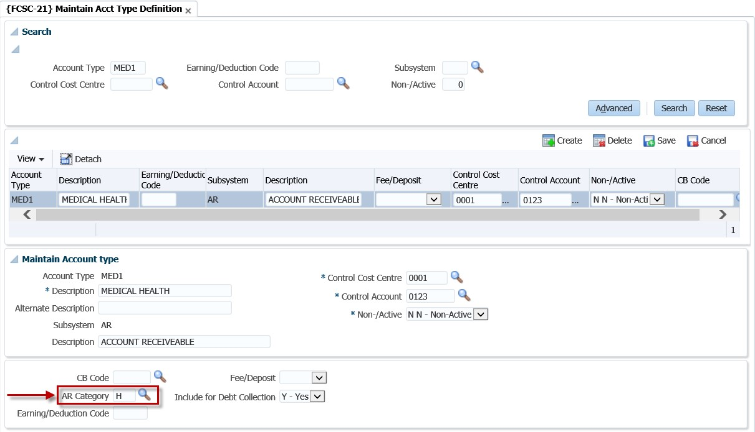

## Maintain Debtors {FARO-21}

Before you will be able to process any transactions in the AR system, the debtor must be defined or allocated a number that will be used when any reports are requested, or transactions are processed for the debtor. This is the option where the debtor will be defined, and the detailed information of the debtor is kept. Access to this option will be restricted and caution must be taken when new records.

**See Example below {FARO-21}**

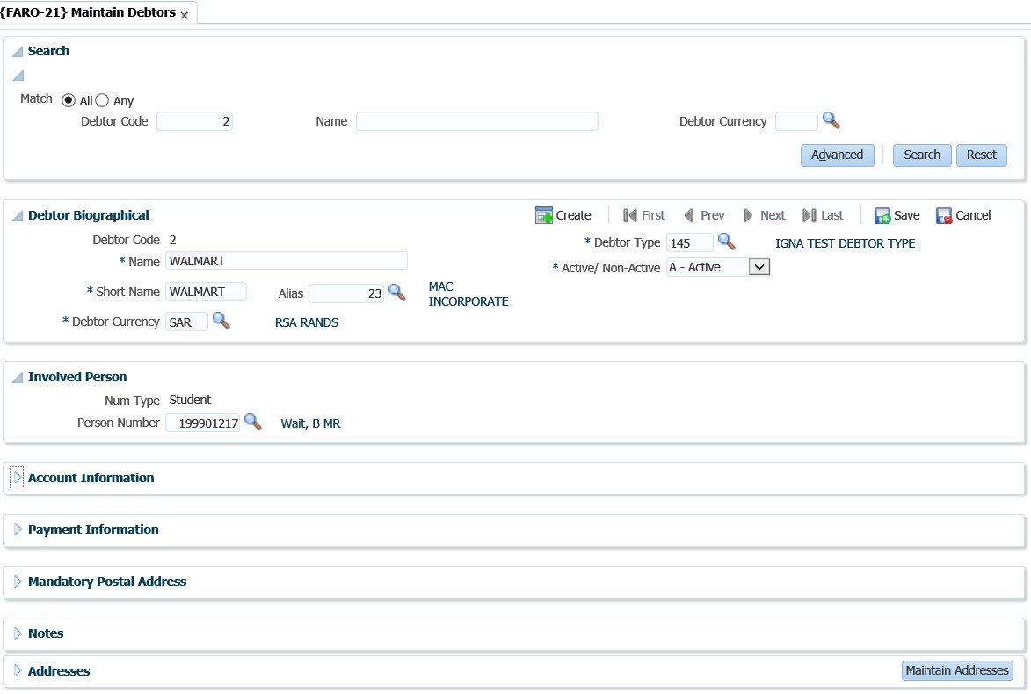

The user can enter the 'Debtor Code', 'Name' and/or 'Debtor Currency' and click on the 'Search' button to view existing transactions for the 'Debtor Code', 'Name' and/or 'Debtor Currency' combinations.

**Panel box 2: Debtor Biological**

**Debtor Code**: The debtor’s unique account number.

**Name**: The name of the debtor

**Short Name**: The first 10 characters of the above name default into this field, but may be altered by the user to be more meaningful. This short name is used for quick reference, display purposes and on some reports.

**Alias**: The alias code (if any) to be used with this debtor, as defined in option {FARO-22}. The alias name will be displayed.

**Debtor Currency**: In which currency should the debtor transactions take place? Use the list function to view the valid currency codes, as created on {FCSO-21}, TAB - Fixed Foreign Currencies.

**Debtor Type**: The code of the debtor type as defined in option {FARC-1}.

**Active/ Non-Active**: Is this account Active or Non-Active? If this indicator is set to Non-Active, the system will not allow any transactions from any subsystems to be entered for this Debtor.

**Panel box 3: Involved Person**

**Num Type**: This field will be completed if the debtor that you are creating, is also used on another sub-system in ITS. This is where you can link the debtor to a Student, Alumni, Personnel or Other. **Person Number**: This is the number for the Person Type selected. The name will be displayed as defined in the sub- system of origin. The list function can be used to display all the valid numbers on the system.

**See Example below {FARO-21}**

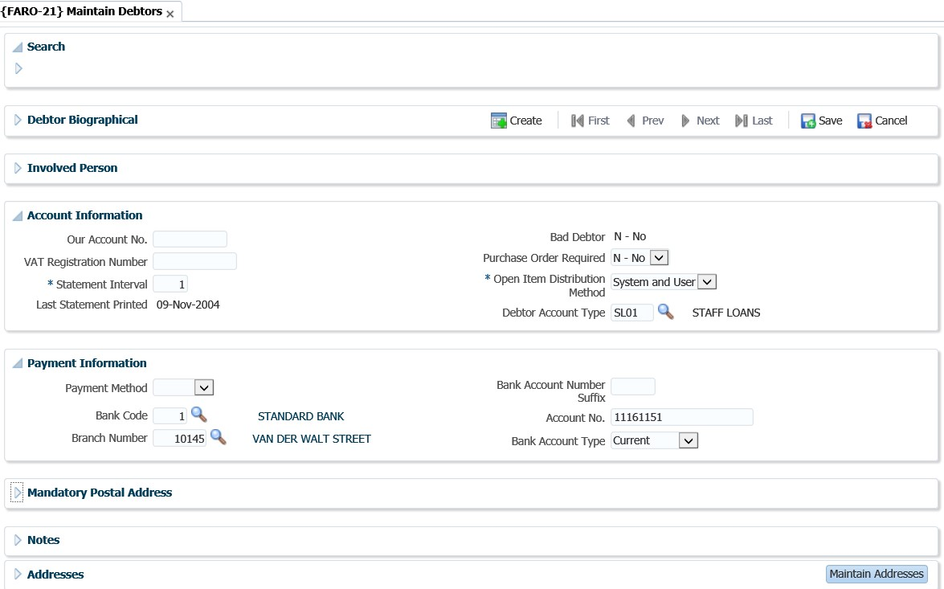

**Our Account No.**: This is the institution's account number with the debtor.

**VAT Registration Number**: The registration number of this debtor, if any. This number will be displayed on a number of reports.

**Statement Interval**: The number of months between printing statements for this debtor. Only 1 to 12 allowed.

**Last Statement Printed**: This field is not accessible to the user but will be updated by the system each time a statement is printed for this debtor.

**Bad Debtor**: Is the debtor a bad debtor Y - Yes or N - No. This indicator is also important for deletion of a debtor. The system will control that a debtor is inactive for at least the number of cycles set as the retaining period of transactions, before deletion is allowed.

**Purchase Order Required**: When using the Student Debtor Contract system, is a Purchase Order required when the student applies or registers for a qualification where the registration or application is linked to a contract that is linked to this debtor. Valid values are Y - Yes or N - No.

**Open Item Distribution Method**: An indicator to show the Open Item distribution method allowed for the debtor. User distribution allowed or System and User distribution allowed.

* System and User distribution allowed:

The System Batch Distribution program will distribute credit documents (receipts etc) to invoices automatically in sequence of the oldest to latest invoices.

* User distribution:

Credit documents must be linked to specific invoices by the User via online maps. (System distribution will not look at these transactions).

**Account Type**: This is the default account type for the debtor as setup in {FCSC-21}.

**Panel box 5: Payment Information**

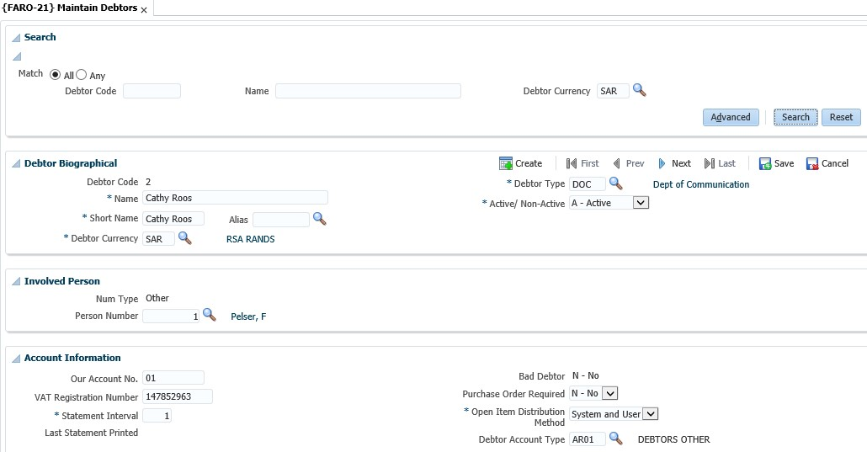

**Payment Method** –This field indicates the debtor’s method of payment; it can be EFT or Cheque.

**Bank Code**: The Bank Code of the debtor’s banking institution.

**Branch Number**: The branch code of the debtor’s bank.

**Bank Account Number Suffix**: Enter a 4-digit number suffix for the Bank Account. Only applies to clients in New Zealand.

**Account No**.: The debtors’ bank account number.

**Bank Account Type**: The debtor's account type. Values are Current, Savings or Transmission.

Displays the postal address of the debtor. You click on the “Maintain Addresses” button in the Addresses panel box to add the postal address of the debtor.

**Panel box 7: Notes**

General notes for the debtor can be added.

**Panel box 8: Addresses**

Displays the address and communication details of the debtor. The Maintain Address button will take you to a form where the addresses can be maintained.

**See Example below**

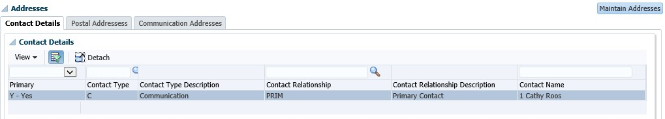

When you click on the “Maintain Addresses” button, the following screen will display and you can click on the “Create” to add an address.

**See Example below**

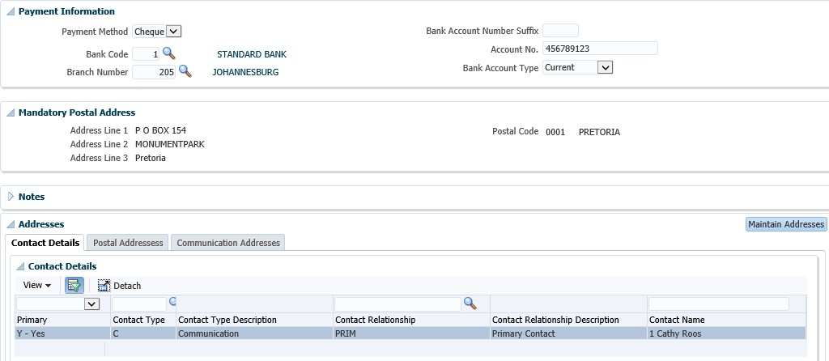

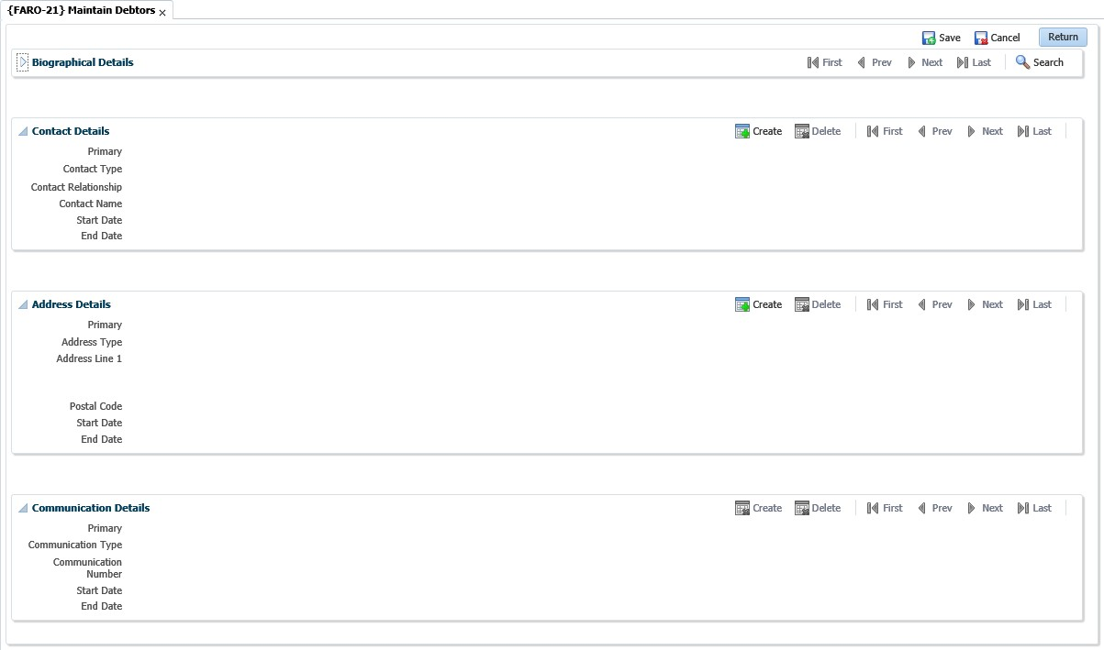

**See Example below {FARO-21}**

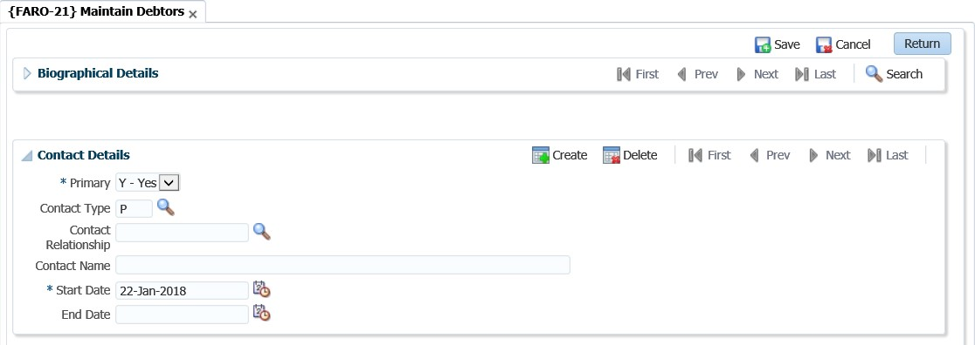

Once you save, the address details will appear in the table.

## Query Types of Documents {FCSO-23}

There are a number of transactions that can be processed on a debtors’ account. The institution must however indicate on this option, which transactions are allowed. Query for ‘AR’ on the field that reads “subsystem”. All the types of transactions will be displayed. There are 8 types of transactions where the user can indicate if this type of transaction is allowed. The 8 types are:

* 1: Credit Transaction
* B: Repeating invoice
* F: Repeating credit note
* I: Invoice
* J: Debit journal
* N: Credit note
* S: Credit Balance
* T: Debit Balance

If the “display sequence” field is left blank, the type of process will not be available. The sequence number allocated will indicate the in which sequence the options will display on



{FARO-1}. The number sequence you allocate does not matter, you can start at 1 and

increment the numbers or allocate numbers as you please. The important thing to look at is the display sequence. The smallest number will display that “document type” first.

**Field in this option**:

**Type**: A unique character as allocated by ITS for each subsystem involved.

**Description**: Description of the Document.

**Short Description**: The English description of the type will be displayed.

**Alternate Description**: The Alternate description of the type will be displayed.

**Debit/Credit**: The debit or credit indicator of this type of Document.

**Subsystem**: The subsystem that uses this type of Document.

**Display Sequence**: The sequence in which the document must appear on the <LIST> function. Referring to the previous image, it would mean the sequence in which the documents would be displayed in {FARO-1} is:

**See Example below {FCSO-23}**

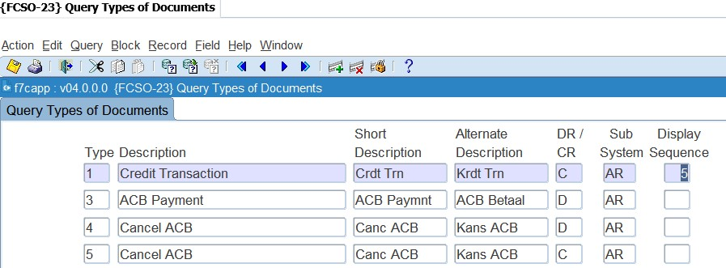

* Manual invoice
* Repeating invoices
* Credit transaction
* Repeating credit note

## Default text on multiple invoices

Should you like to print generic text on the invoices you print for the debtors, you have to access menu option {FAROR1-1} or {FAROR1-12}.

## Invoices to be Sent {FAROR1-1}

This is the option that allows you to print (or re-print) invoices. Styles sheet are added to the option to include header and footer as part of the invoice. The program can include a note as part as the Invoice. The note is obtained either from a note created in the Debtors Correspondence {FDCO-1} or a paragraph where a note is created in an RTF format and loaded into the system and converted to a style sheet {GMNT-14}.

The default note is the note code or paragraph include linked to the SOD code NI subsystem AR. To create a paragraph, include type note, create the note in MSWord, save the note as RTF. In {GMNT-14} enter a note code, description (description may note contain spaces) and document classification (paragraph include class is PINC) and date, load and convert the RTF document (Retrieve from Client button).

Access the option {FAROR1-1}. Enter the values as requested from the different parameters. The parameter that asks “add default note” you will indicate yes. The note that you have created and linked to the parameter in {FCSM-1} will print with the invoice.

**See Example below {FAROR1-1}**

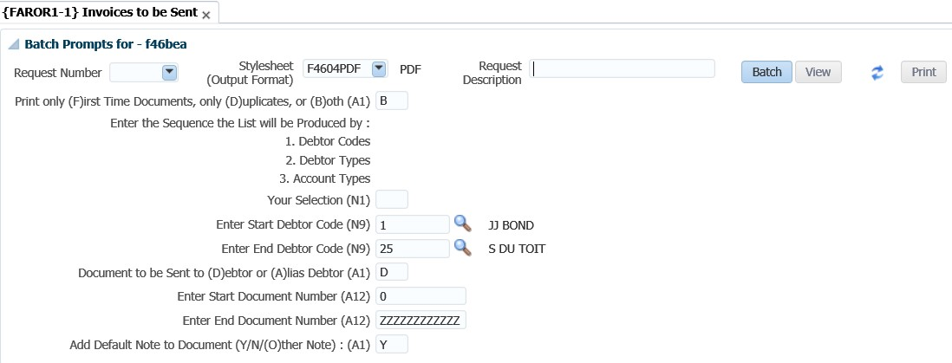

**Print only (F)irst Time Documents, only (D)uplicates, or (B)oth:** First time documents have not yet been printed and therefore have not been flagged as printed. When documents are printed for the first time these documents are flagged as printed by the program. Duplicate documents will reprint documents that have previously been printed. These documents are flagged as printed. Both will reprint previously printed documents as well as first time documents.

**Add Default Note to Document:** When you select (Y)es, the note is obtained from a note created in the Debtors Correspondence {FDCO-1}. The default note is the note code linked to the SOD code NI subsystem AR. You go to the option “Maintain system operational definitions”: {FCSM-1} tab 2. Query the code “NI” and link the document code created above to the “Default Note to Print Invoice” code.

**See Example below {FCSM-1}**

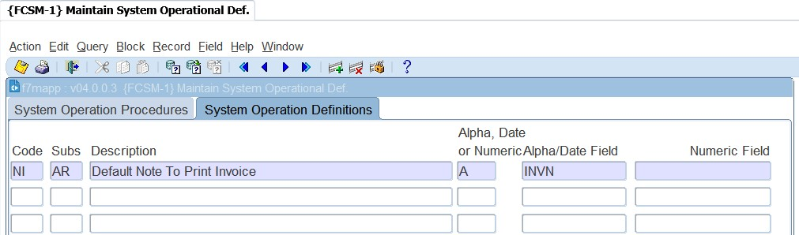

To create a paragraph, include type note, create the note in MSWord, save the note as RTF. In {GMNT14} enter a note code, description (description may note contain spaces) and document classification (paragraph include class is INC) and date, load and convert the RTF document (Retrieve from Client button).

You can also select to not to use the default note i.e. on the parameter that requests “add default note” you will indicate “O”ther.

**See Example below {FAROR1-1}**

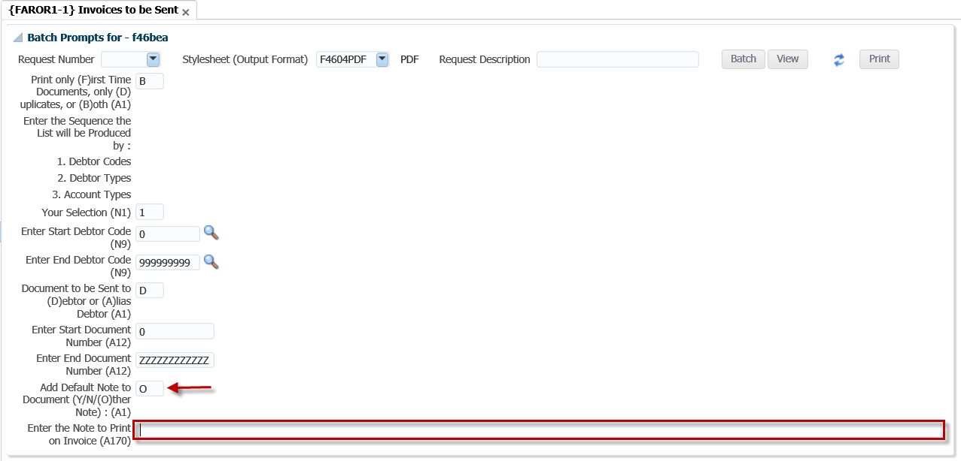

**Add Default Note to Document:** If the answer is O, then enter the note to print on invoice in the field that follows.

**Enter the Note to Print on Invoice**: The actual text that you want to appear on the invoice.

**Batch button**

You can proceed in immediate or deferred batch mode and the View / Print buttons will become active.

**See Example below {FAROR1-1}**

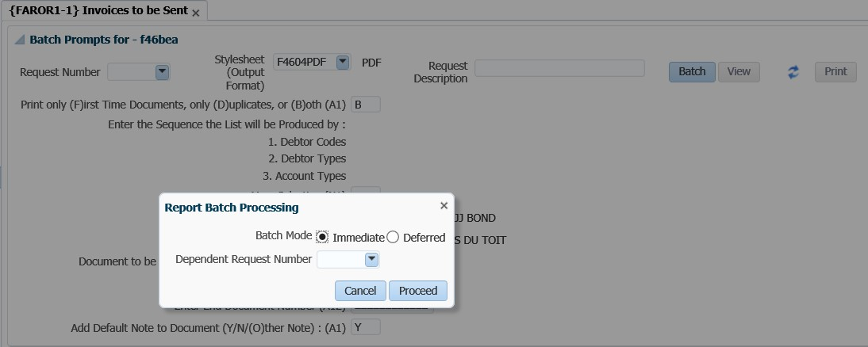

The user can opt to view or print the report generated.

**See Example below**

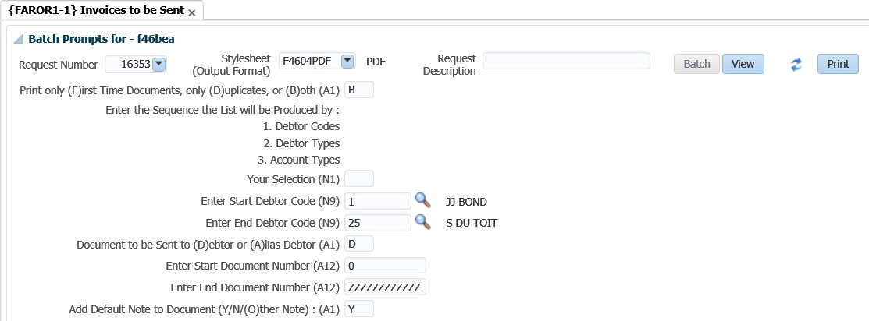

## Consolidated External Debtor Statement – NCR Format {FAROR1-12}

This option is based on the selections criteria of previous debtor statements and it is designed for external use. The output is based on the iComms concept and users may design their own layout. Statements can be generated sequentially per debtor or unique statement numbers. A new option based on the selections criteria of previous debtor statement and it is designed for external use. The output is based on the iComms concept, users may design their own layout.

Notes that are recorded against a debtor can be printed on the statement. The note category 'ZPDN' is and ITS category called Public Domain Notes and cannot be restricted. The note category 'ZPDN' and note code 'ITSSTMD' must specifically be used when notes are created that must print on the Debtor Statements. Only notes linked to this category will print on statements. All notes that are linked to this category where the note status is null will print on the student statement

**Enter Comment Line 1 to print on Statement**: The actual text that you want to appear on the invoice.

**See Example below {FAROR1-12}**

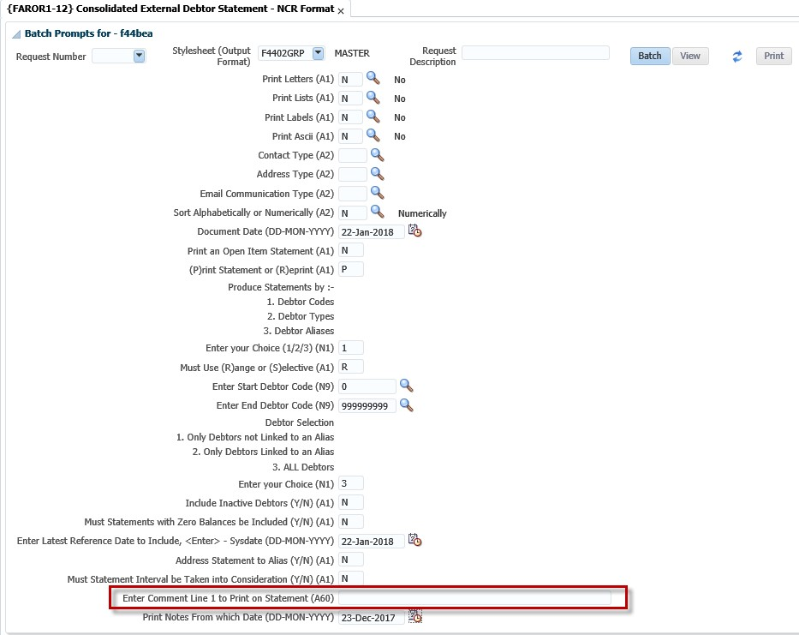

## Query debtor transactions {FARO-3}

This option is not only used to query all transactions of the debtor, but also has the functionality

available to drill down to detailed transaction.

**See Example below {FARO-3}**

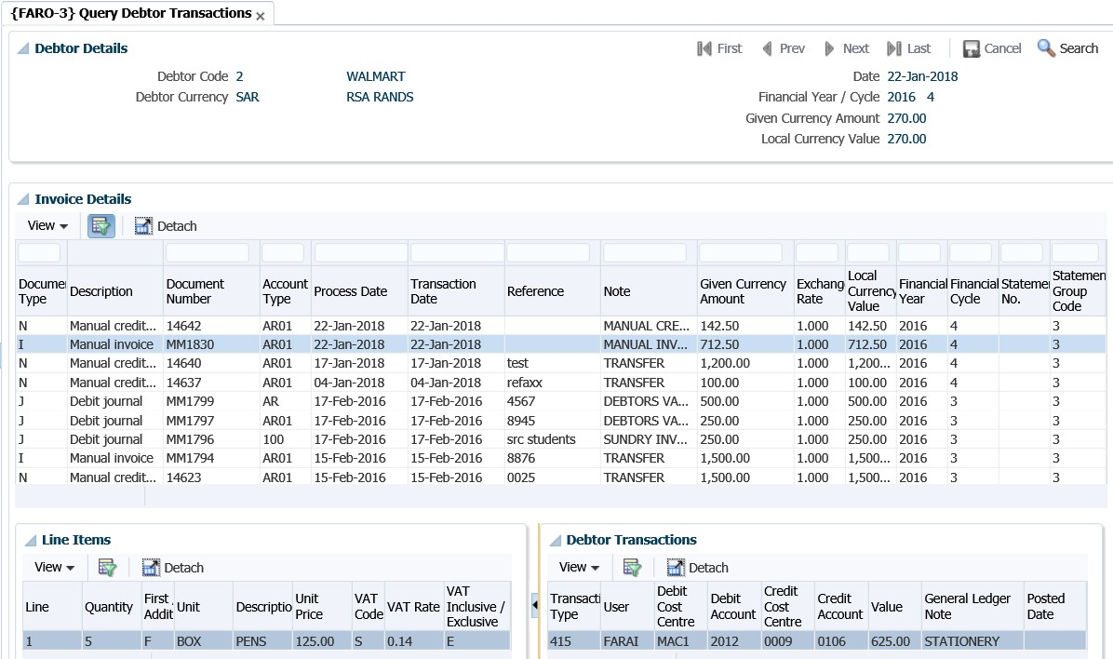

When the user selects a debtor from a search, the details of the debtor are displayed in this panel box.

**Invoice Details**

This panel box will display all the documents for the debtor selected in Debtor Details. The invoices of the debtor display in the table and are not updatable. If you wish to see the detail of a specific transaction in this panel box, you click on the transaction and the financial details will display in the Line Items and Debtor Transactions panel boxes.

**Line Items**

All the line items of the document selected in the Invoice Detail panel box are displayed here.

**Debtor Transactions**

The general ledger allocation details of the document selected will display here.

Transactions will be displayed from the latest transaction date to the oldest. The type code is the same codes that are used in {FARO-1}.



## Calculating interest on debtor balances

Interest is calculated per debtor type linked to the account type. The debtor type will be linked to the debtor as well as to the account type. Interest can be calculated on a monthly basis. Below are the steps to follow should you wish to charge interest to the debtor accounts.

**Step 1: Maintain debtor types {FARC-1}**

The debtor type will be linked to the debtor in {FARO-21}. The debtor type is primarily used to “group” the debtors. The reports do make provision for requesting per debtor type. An example of debtor types that can be used are, “Normal debtors”, “Student debtors” and “Sundry debtors”.

**See Example below {FARC-1}**

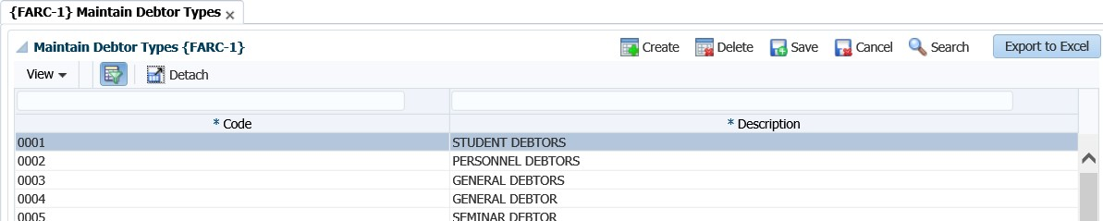

**Step 2: Maintain interest parameters {FARM-1}**

The system makes provision to charge interest for different debtor types per account type. This means that different interest can be charged for sundry debtors than for SRC debtors. You will specify the interest rate applicable per debtor type for transactions recorded on a specific account type. Interest rates can be specified for current, 30-60 days, 60-90 days and 90 days plus. Remember that the transaction date will be used to do the ageing when calculating interest. If you don’t want to charge interest you will set the fields to zero.

**See Example below {FARM-1}**

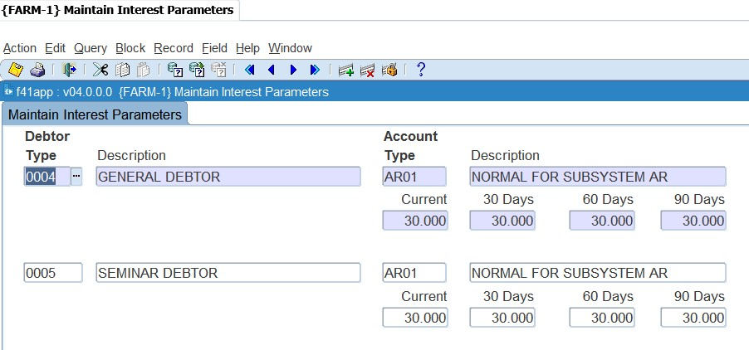

**Step 3: Calculate interest {FARO-6}**

Before this can be used for the first time, the user should link a transaction type to event ‘FU’. (see section on example of transaction types above on what GLA’s should be used.) For debtors that are flagged as an Open Item usage debtor, aging will be done for each invoice. The functionality of Open Item enables the system to do aging of outstanding amounts for debtors at invoice level. The option is in a “report format” and the system will ask the following parameters:

**See Example below {FARO-6}**

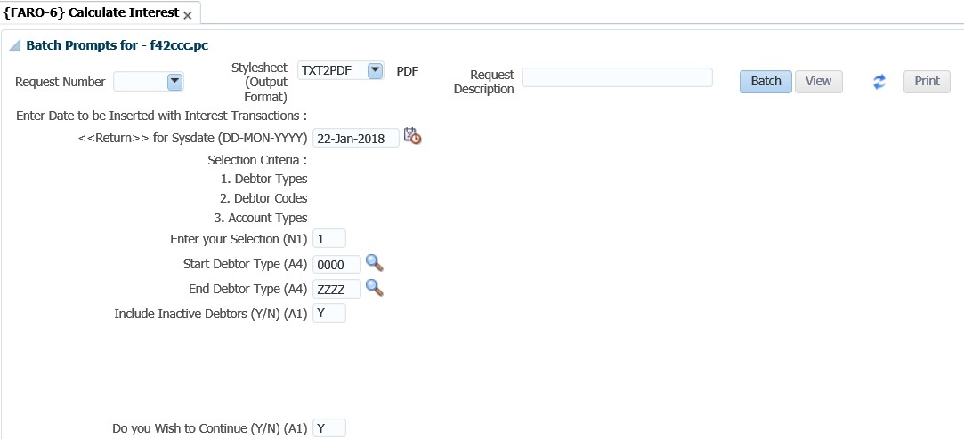

**Enter Date to be inserted with interest transactions**: <RETURN> will default to system date: This date will be used for ageing of the interest transaction.

**Previous Interest transactions to be included**: Note that a (Y)es will result in interest being calculated on interest. If your institution does not follow this compound interest policy, always reply (N)o to this question.

**Step 4: Rollback interest calculation {FARO-7}**

This option allows for the rollback of interest as calculated in {FARO-6}. The option will control that the transactions have not yet been posted to the GL. If it was posted, the system will abort with a message.

**See Example below {FARO-7}**

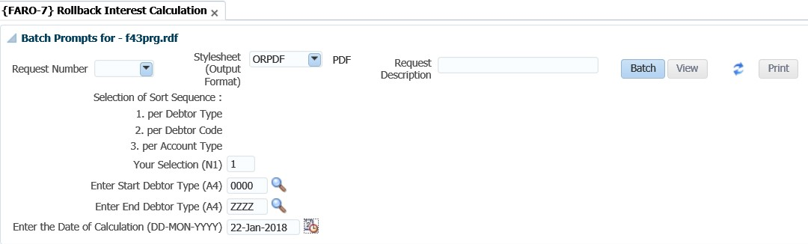

The selection allows selective rollbacks per debtor type for interest calculations done on the same date.

**MODULE**

**5**

# Journals

**Specific outcomes**

On completion of this module, you will be able to:

* Generate batch journals.
* Execute inter-account transfers.
* Maintain no-show indicators.
* Perform electronic approval of transactions.
* Utilise the open item functionality.

## Introduction

In the previous section we had a look at individual transaction processing. That means where you would either process an invoice or journal for an individual debtor. In this section we will look at the functionality available where you can process journals for more than one debtor simultaneously.

## Batch journals {FARO-29}

This is used to process transactions/journals for different debtors with one journal/voucher number. The option can also be used to process transactions for individual debtors. This option allows the user to capture batch journals manually or to duplicate a previously captured journal by searching for the journal and then clicking on the 'Duplicate Journal' button, as well as importing a journal from a csv template.

The 'Create CSV template' button allows the user to download a journal template from the option. The user can then fill in the template with the journal details, then upload the file back into the option. This is useful where staff recoveries (for example telephone usage) must be made. If a list of staff members and the cost to be recovered is available, the application allows for quick capture of such a list.

**See Example below {FARO-29}**

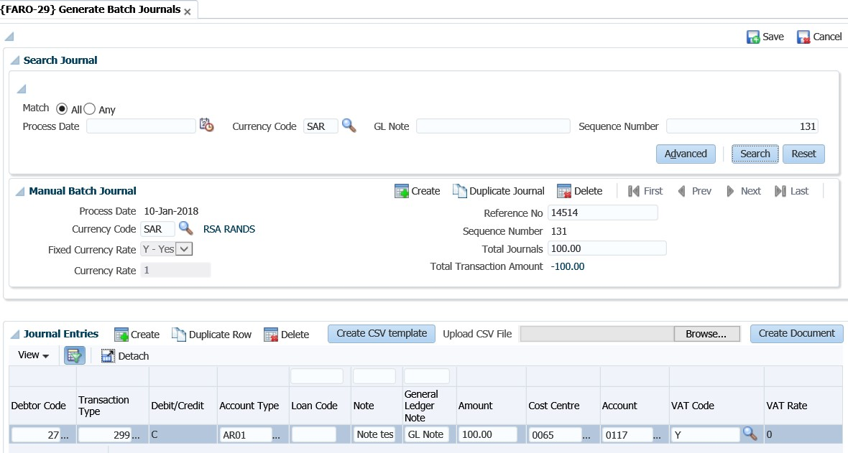

**Process Date:** Processing date of the journal.

**Currency Code:** Currency code for this journal.

**Currency Rate:** Currency rate for this journal.

**Fixed Currency Rate:** Is the exchange rate fixed? Values are Y - Yes and N – No.

**Reference No:** This is a user defined reference number used to reference the batch journal to its supporting documents.

**Sequence Number:** This is a system generated number.

**Total Journals:** Total amount of the journal to be processed. (If it is for foreign purposes, enter the amount in foreign currency). If this is a credit Journal, the amount must be captured as a negative e.g. -10000.00.

**Total Transaction Amount:** The total of the transactions in the Journal Entries panel box will be displayed.

**Journal Entries**

**Debtor Code**: The code of the debtor as defined in {FARO-21}.

**Transaction Type**: Transaction type to be used for this journal. Created in {FCSO-7}.

**Debit/Credit:** Is this transaction a (D)ebit / (C)redit? This field is populated systematically from the debit/credit indicator of the transaction type.

**Account Type:** Account type for the debtor transaction. Created in {FCSC-21}.

**Loan Code:** The loan code from which the staff recovery will be made if applicable. The link between the loan and account type can be found in {FARS-1}.

**Note:** The transaction note to print on debtor statement for this journal.

**General Ledger Note:** The note that will appear in the general ledger.

**Amount:** The transaction amount for this debtor.

**Cost Centre:** Cost centre for this transaction. Created in {FCSO-1}.

**Account:** Account for this transaction. Created in {FCSO-3}.

**Vat Code:** Vat code for this transaction.

**Vat Rate:** This field is populated from the VAT Code.

**Transaction Group Code:** Transaction Group Codes are defined in option {FARC-4} and linked to AR Document Types in option {FARM-3}. The system will default the Group Code linked to the document as defined in option {FARM-3} and if it is updateable there, then the user may change it.

**Note**: Saving a journal will not write it to the debtor’s account, regardless of whether the Total Transaction Amount balances to the Total Journals amount. In order to have the journal reflect on the debtor accounts, the user will have to click on the 'Create Document' button.



## Inter account transfers {FARO-2}

Should you have processed journals/transactions to the wrong debtor account, you can always make use of the inter account transfer option to process transactions between debtors. This option simplifies the process by capturing one transaction instead of different journals on option {FARO-1}. The option also allows you to transfer amounts between different subsystems.

**See Example below {FARO-2}**

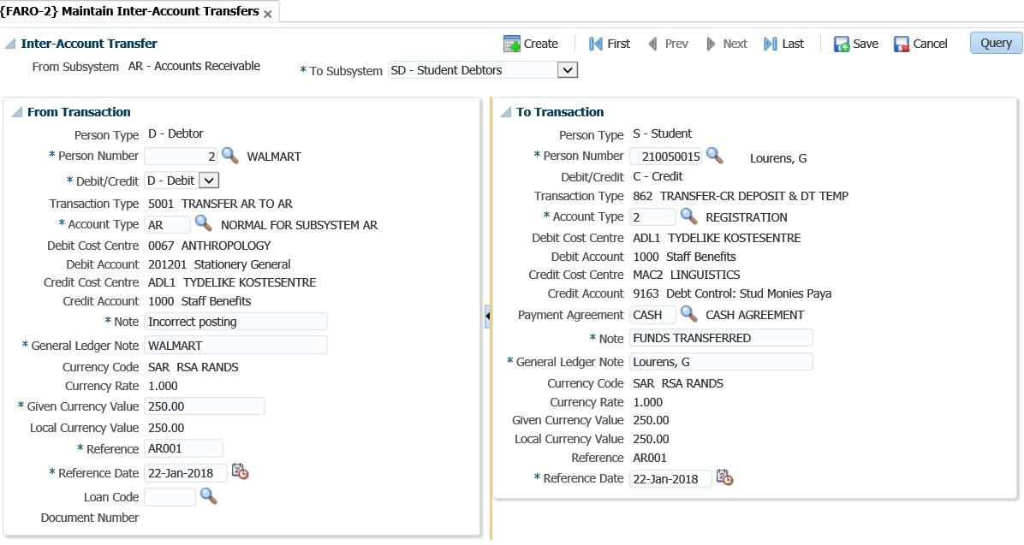

**Main Inter-Account Transfers**

**From Subsystem**: The user must select the subsystem where the information must be transferred from. You have the option to select between AR, SD or CM.

**To Subsystem:** The user must select the subsystem where the information must be transferred to. **Date:** Defaults from the system date.

**“From Transaction”**

**Person Type**: This field will default depending on the subsystem that was selected in the previous tab. Where the subsystem AR is selected, this field will display a D for the debtor.

**Number:** Complete the debtor code from which account the transfer must take place.

**C/D:** What must happen to this debtor? Would you like to debit or credit his account? The system will simultaneously enter the opposite indicator on the next tab.

**Transaction type**: The system will insert the TT automatically. This is because the option works with a transaction event that is linked in {FCSO-7}.

**From account type**: Specify the account type that the amount must be transferred from.

**Note**: This is the description that will appear on the statement for the transaction. It is advised that it is descriptive enough so that the debtor would understand what happened.



**Value given currency**: Enter the amount that should be transferred.

**Reference date**: The system date defaults into the reference date but can be updated by the user.

**“To Transaction”**

The panel box is similar to the adjacent panel, the only difference is that the former contains the ‘To’ information. The user will complete the debtor code for the other person to be updated with this transaction. Other fields are not updatable as they default from the “From Transaction” panel box.

## Maintain no show indicators {FARO-4}

Should you have made a mistake when processing a transaction against the wrong debtor, you can use this option to “hide” the mistake. In the previous section it was explained how to transfer between debtors’ accounts. If statement number is in use, then the system will only display records that are not linked to a statement number. The reason: Once a document is linked to a statement the user is not allowed to change no-show indicators.

**See Example below {FARO-4}**

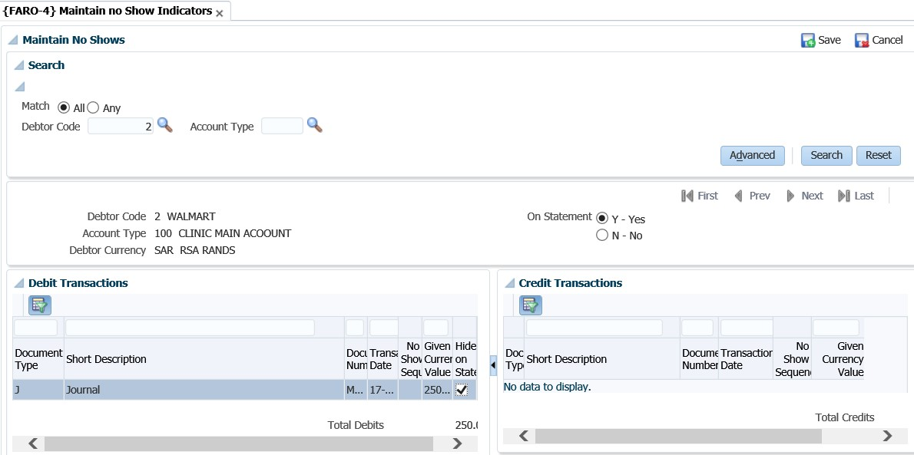

The user will have to enter the debtor code and the account type (optional) as search criteria.

**TAB 2**

You can either select “Yes” to view all transactions on the statement or “No” to view transactions that have already been ticked and thus do not appear on the statement.

**Debit / Credit Transactions**

Will display all the debit / credit transactions for an account type and only the 'Hide on Statement' indicator can be updated. A blank field means that the item will be printed.

**Note**: The system will validate that the no-show transactions balance. That means that the debits and credits are equal. So, before you can save the transaction the option will show the totals in the control tab at the bottom of the screen.



## Electronic Approval of transactions {FARO-11}

This option will be used if the system operational parameter (in {FCSM-1 b2}) ‘EA’ (AR journal approvals) is set to us(E)rs. Only users that are defined as staff members on the personnel system can be linked on {FCSM-5} to “approval privilege”. In addition, the users can also be restricted in {FCSO-4} to approve only certain amounts, cost centres or departments.

**See Example below {FARO-11}**

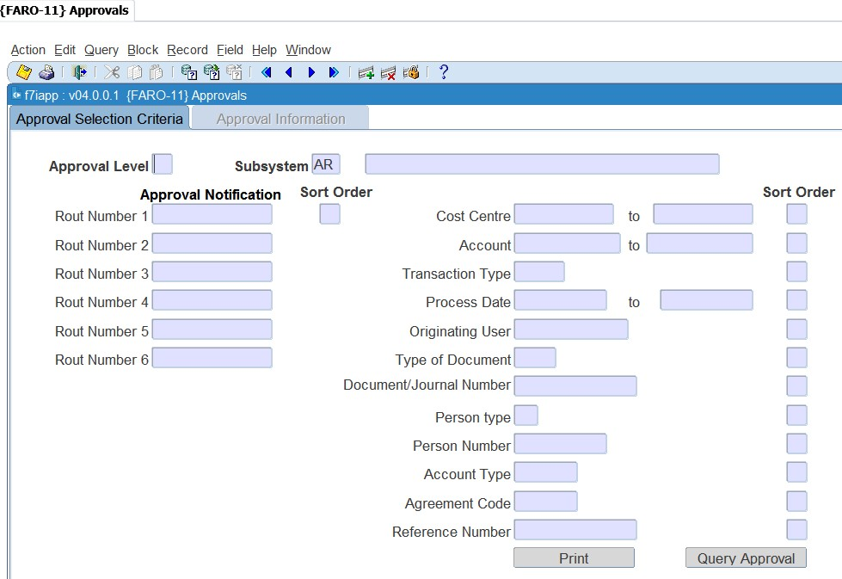

Multiple criteria can be used to query transactions and sort priorities can be given to selection criteria. In tab 1, the user will enter the criteria for the system to query the transactions to be approved. It is optional to indicate what the sort order must be for the transactions to display on the second tab.

**Note**: You must at least indicate in one of the fields what the sort order is before continuing to the next tab. All the transactions that have not been approved yet, will display on the next screen according to the criteria specified.



**Approval Information**

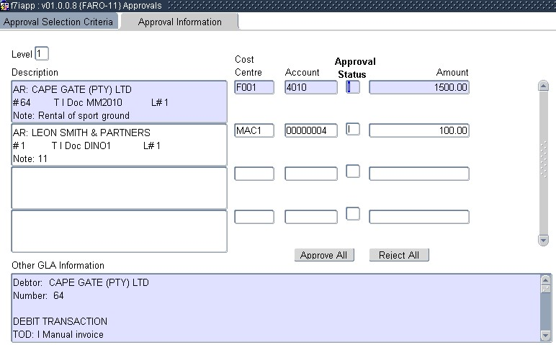

In this screen you can:

* Approve or reject individual transactions. You will select the specific transaction and change the status to A or R or I.
* Approve or reject all the transactions in batch. Click the applicable button at the bottom of the screen.

**Note**: Should you wish to see more detail of the transaction, the detail of the transaction is displayed at the bottom of the screen. When you use the scroll bar on the right of the screen you can view all the transaction detail.



## Open item functionality

“Open Item Distribution” is the functionality to link credit transactions (receipts, cheques, credit notes etc.) to a debit transaction (or invoice). Multiple credit transactions can be distributed to one invoice, or one credit transaction can be linked to multiple invoices. A debit transaction (invoices etc.), where the full document amount is not linked to credit transactions, is referred to as an open item. A debit transaction (invoice etc.), where the document amount is fully linked to credit transactions is referred to as a closed item.

**Note:** By using this functionality, you will be able to not just show the specific outstanding invoices, but also to age the debtor more accurately. When the open item functionality is not used, receipts are “allocated” to the oldest debt first.



### Debtor Transactions {FARI-1}

This option will select and display all the debtors in the open item control table for distribution or maintenance. From this screen the user can access the "Open Item Distribution" and "Open Item Maintenance" options.

The menu option will only be able to be used if the system operation definition ‘OI’ (AR - Open Item Y/N) for sub-system ‘AR’ is set to (Y)es in the menu {FCSM-1 }Tab 2.

**See Example below {FARI-1}**

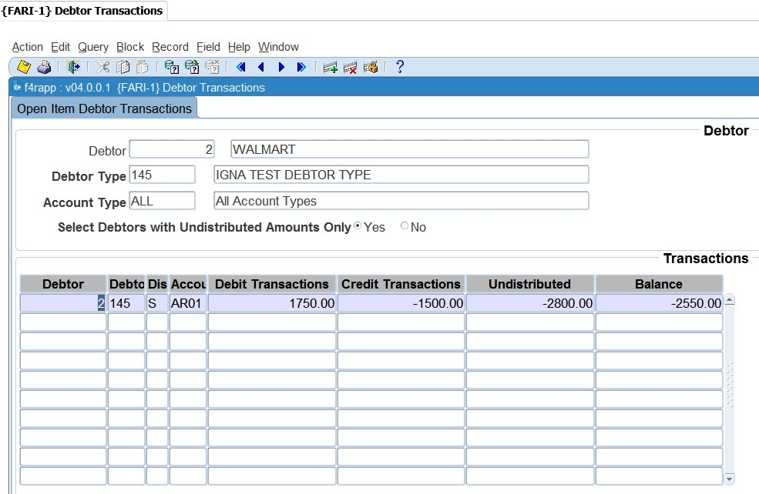

**Open Item Debtor Transaction Selection**

This tab will be used to determine which debtors, debtor types and account types will be selected for processing in the next tab. Debtor / Debtor Type / Account Type will determine the transactions that will display in the next tab. Select Debtors with undistributed amount only (Y/N) will determine if all debtors or only those with undistributed amounts outstanding will display.

**Open Item Debtor Transaction Detail**

The detail data will be selected from the open Item control table according to the selection criteria from tab1. The debit, credit and undistributed transactions will be summarized, and the balance calculated for each debtor and account type combination.

**See Example below {FARI-1}**

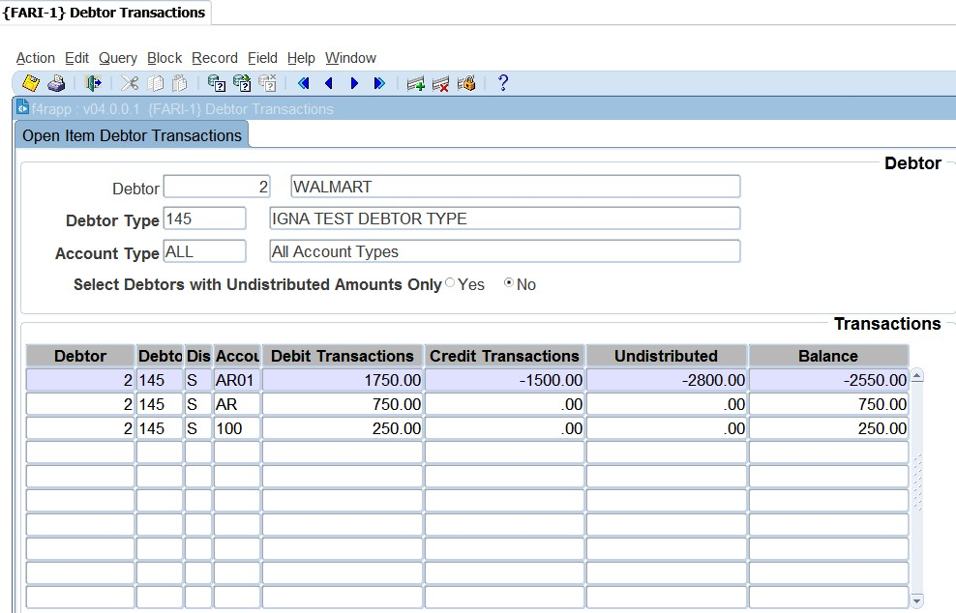

When you right click on the debtor code, you will be able to drilldown to the following menus:

* Maintain Debtor {FARO-21}: update the debtor details
* Query Debtor Transactions {FARO-3}: check the debtor’s transactions and balance
* Open Item Distribution {FARI-2}: distribute credit transactions to a source document (invoice)
* Open Item Maintenance {FARI-4}: unlink a credit transaction from an invoice

**Open Item Distribution**

Open Item Distribution refers to a process of allocating distribution records for credit transactions in the Open Item table for selected debit transactions (payments / receipts to invoices etc.) and two methods of distribution will be available:

* **Batch System distribution**: This is the distribution of all or a selection of undistributed credit transactions. The system will allocate the credits to debit transactions that are still available (open items) from the eldest to latest date for a specific or all debtors. The distribution may be performed in one of the following ways:
  + Full System Distribution: This is the distribution of all undistributed credit transactions for selected debtors to all open invoices for the same debtor
  + System Distribution: This is the distribution of selected undistributed credit transactions for a selected debtor to all open invoices to be cleared from the eldest to latest date.
* **Manual User distribution**: This method distributes selected undistributed credit transactions for a selected debtor to selected debit transactions (invoices etc.) for the debtor.

**See Example below {FARI-1}**

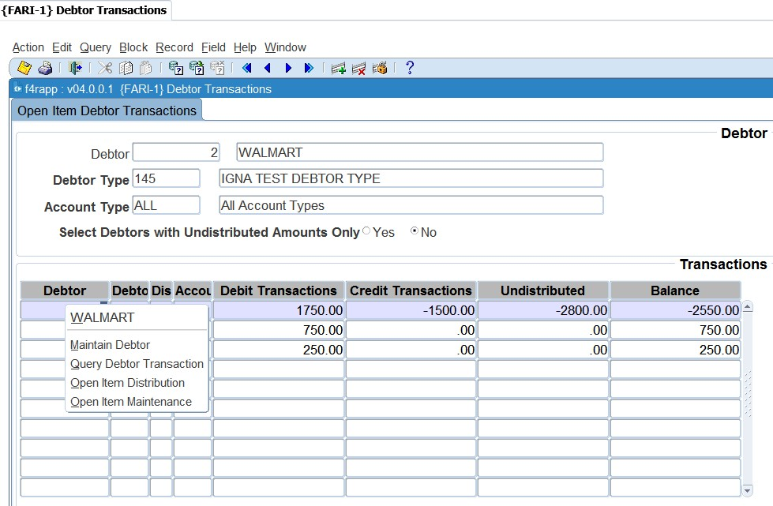

**Open item Maintenance**

If you made a mistake with the linking, you can edit this by using {FARI-4}. This will however depend on the system operation definition indicator ‘OM’ is set to ‘YES’.

**See Example below {FARI-1}**

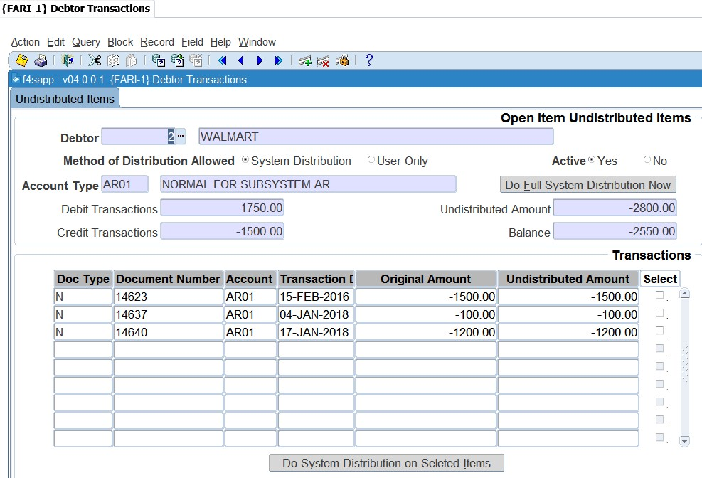

### Undistributed Items {FARI-2}

Open item distribution is the functionality of linking credit trans. (receipts, cheques, credit-notes etc.) to an invoice with an outstanding balance. Various credit transactions can be distributed to 1 invoice or 1 credit transaction can be distributed to various invoices. An invoice with no outstanding balance will be, with its linked credit trans., flagged as a closed item.

**See Example below {FARI-2}**

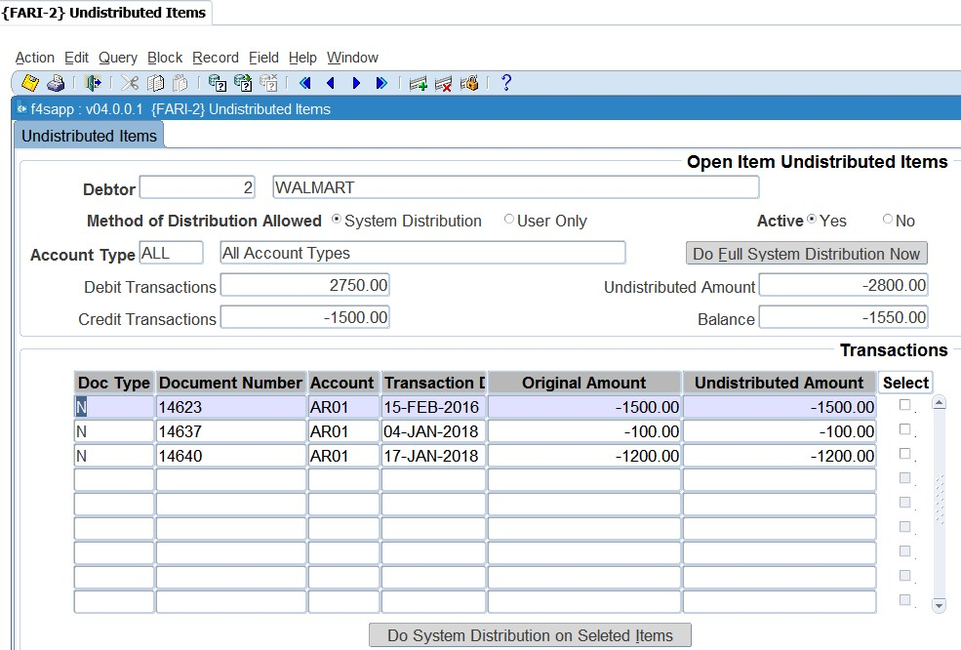

Select the debtor for which the distribution will be done. The transactions that will display in the next tab are dependent on the account type. If ALL is specified, all transactions for all account types will display. The Do Full System DistributionNow button will distribute all undistributed credit transactions to invoices with outstanding balances for the specific debtor and account type.

**Transactions**

All undistributed transactions for the debtor and account type combination will be displayed and available to use for distribution. Select the transactions that must be distributed with a tick in the check box. As soon as the ‘Do System Distribution’ button is hit, all flagged credit transactions will be distributed to the invoices with outstanding balances. The selection and processing of the credit transactions and invoices will be in date sequence from the earliest to the latest date.

**6.6.3** **Distribution Items {FARI-3}**

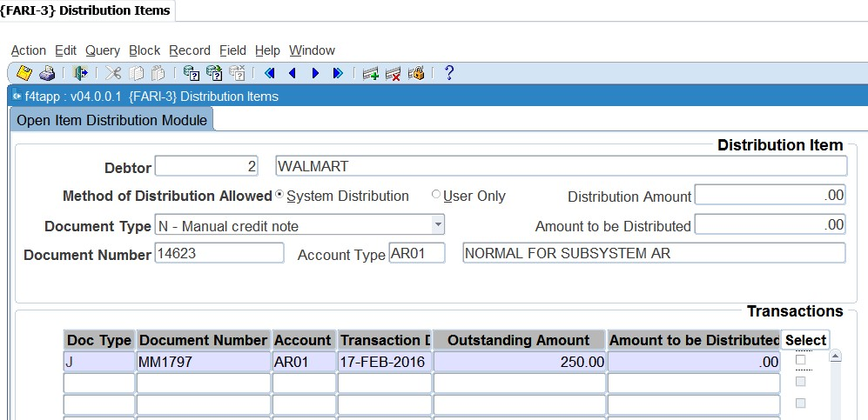This option will distribute any undistributed transactions to invoices with outstanding balances. The option will be available if the system operational parameter ‘OI’, AR: Open Item Y/N, is set to ‘Y’es in {FCSM-2}Tab. One the document amount is fully linked to credit transactions is referred to as a closed item.

**Distribution Item**

This tab will be used to determine which debtor and account types will be selected for distribution processing in the next tab.

**Debtor:** The debtor code entered into this field will determine which debtor transactions will be displayed in the next tab.

**Name:** The debtor name will be displayed in this field.

**Method of Distribution Allowed:** The method of distribution allowed as defined on the debtor, "Maintain Debtors" {FARO-21}.

**Document Type:** The document type of credit transaction available for distribution.

Document Number: The document number of credit transaction document available for distribution.

**Account Type:** Displays the account type of the document selected for distribution.

**Description:** Account type description. (Display Item). The account type description will be displayed in this field.

**Distribution Amount:** An undistributed amount available for distribution for the debtor and document.

**Amount to be Distributed:** A calculated total of all the amounts selected in tab 2 to be used for distribution. This is a running total, which will be updated continually as invoices are selected to be cleared in Tab 2. This value cannot exceed the Distribution Amount or be less than zero.

**Note**: +It is recommended that a specific document type is selected from the drop-down menu to make it easier to find the “document number” in the next field. Enter the document number of the document that must be distributed to the relevant documents in the next tab.



**Transactions**

The transactions that are displayed in this tab will be determined by the selection criteria from the first tab. All invoices that are displayed are invoices that are still outstanding, thus not yet linked to a payment or credit transaction. All the fields are display fields only; the only updateable field is the ‘Amount to be Distributed’. This amount cannot exceed the ‘Amount Available’ and can be altered by the user. The ‘Select’ field can be “clicked” on. When the users click/tick the box the system will display the ‘outstanding amount’ in the ‘Amount to be distributed field’. As the user clicks, the ‘Distribution Amount’ in the first tab will be updated till the full amount is distributed.

**See Example below {FARI-4}**

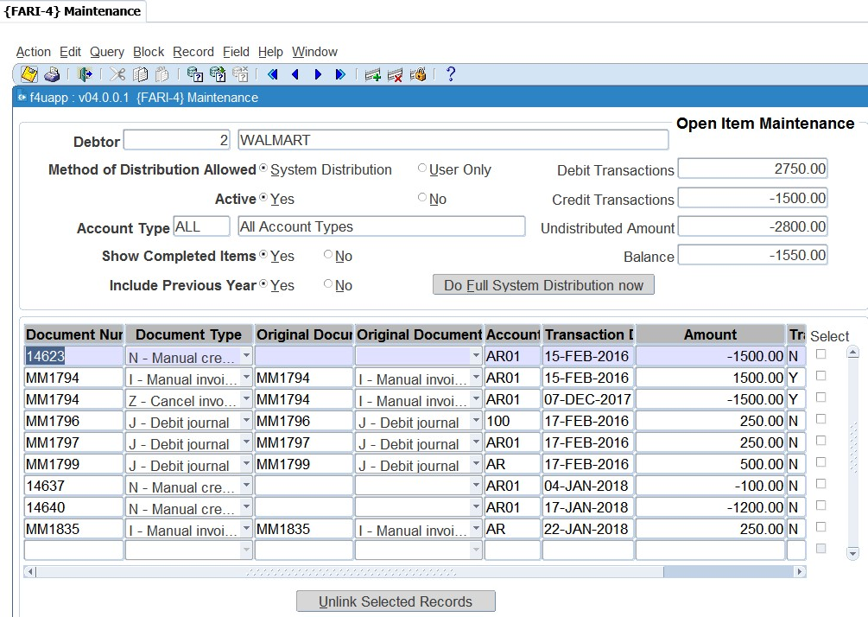

**See Example below**

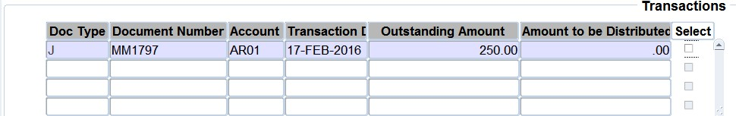

**Document Type:** The document type of the document with an outstanding balance that can be linked to an undistributed transaction.

**Document Number:** The document number of the document with an outstanding balance that can be linked to an undistributed transaction.

**Account Type:** The account type of the document with an outstanding balance that can be linked to an undistributed transaction.

**Transaction Date:** The date of the document with an outstanding balance that can be linked to an undistributed transaction.

**Outstanding Amount:** The outstanding amount of the invoice that can be linked to an undistributed transaction.

**Amount to be Distributed:** This is the amount selected, or entered, that will be distributed to the Invoice. This amount cannot exceed the outstanding amount, nor be less than zero.

**Select:** This check box will allocate the value of the outstanding amount field to the amount to be distributed field. It will also deduct this value from the amount to be distributed field in tab 1. The user will be able to continue distributing the available distribution amount to various invoices until the total amount to be distributed is zero.

**Note:** Once you have selected the right documents, you can save the record. The system will then link these documents to the credit document from the first tab 1. If you made a mistake with the linking, you can edit this by using {FARI-4}. This will however depend on the system



operation definition indicator ‘OM’ is set to ‘YES’.

**See Example below {FARI-4}**

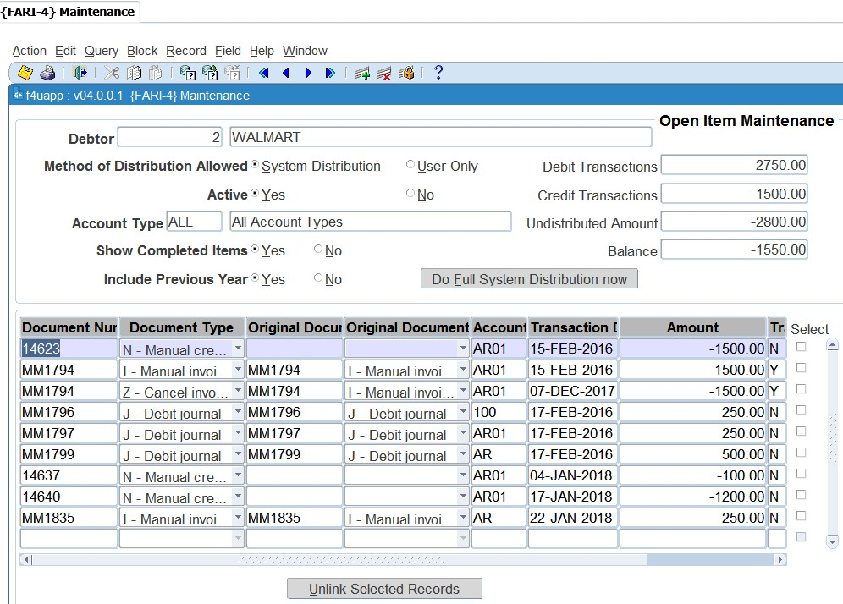

The option will display all ‘open items’ for maintenance. This option can also be accessed from {FARI1}. The option will only available if the system operational parameter ‘OI’ in {FCSM-1 b2} was set to ‘Y’es. Where option {FARI-3} was used to link credit transactions to an invoice this option is to “unlink” the credit transaction from the invoice. This means the credit transaction will be available again to use in {FARI 3}.

This tab will be used to determine which debtor and account types will be selected for distribution processing in the next tab.

**See Example below {FCSM-1}**

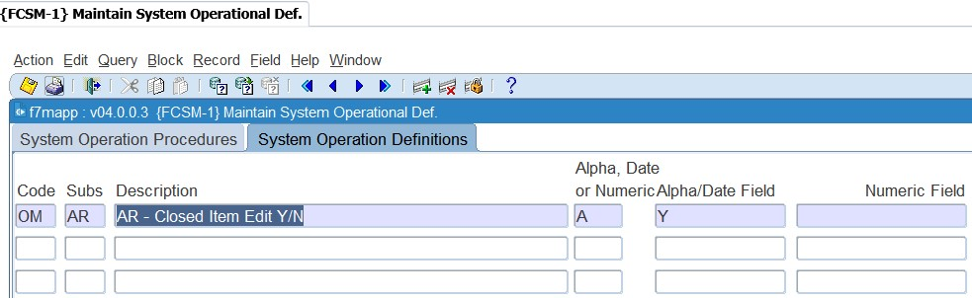

**Debtor:** The debtor code entered into this field will determine which debtor transactions will be displayed in the next tab. LoV displays one record for each debtor found on the Open Item control table, with their names.

The following exist in the pop-up menu:

* Maintain Debtor {FARO-21}
* Query Debtor Transactions {FARO-3}

**Method of Distribution Allowed**: The method of distribution allowed that is linked to the above debtor.

**Active Yes / No:** Indication of whether the debtor is currently flagged as active or inactive.

**Account Type:** The account type entered in this field name will determine which debtor transactions will be displayed in the next tab. If ‘All’ is entered, transactions for all account types will be displayed. LoV displays all the account types and their descriptions that are available for distribution for this specific debtor.

**Show Complete Items Y/N**: The indicator will determine if transactions marked as complete will be displayed and available for maintenance in the next tab. Completed transactions are also referred to as Closed Items. An invoice and its related transactions will be considered as Completed transactions (the invoice can also be referred to as a Closed Item) when the outstanding invoice has a zero-calculated balance (the sum of all the debit and credit documents linked to an invoice is zero). Once an invoice is considered as a Closed Item, the invoice together with its related documents, will be flagged as a completed transaction.

**Include Previous Years Y/N:** The indicator will determine whether only the transactions relating to (the current financial year or all the transactions) will be displayed and available for maintenance in the next tab.

**Debit Transactions:** A total of all the debit transactions for the debtor and account type.

**Credit Transactions:** A total of all the credit transactions for the debtor and account type.

**Undistributed Value:** A total of all the undistributed values for the debtor and account type.

**Balance:** The calculated outstanding balance for the debtor and account type.

**Do Full System Distribution now:** The functionality of this push button is to distribute, in background, all undistributed credit transactions to invoices with outstanding balances for the specific debtor and account type. The credit transactions, and similarly the invoices, will be selected and processed in date sequence from the earliest to latest date.

**See Example below**

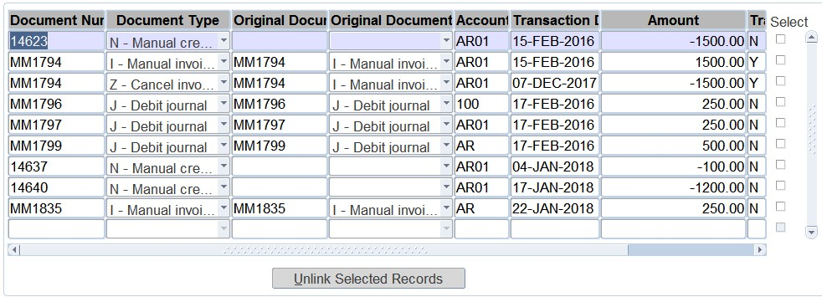

**Document Number:** The document number of the document selected document. The following is available on the pop-up menu:

* Transaction Note
* User Distribution. This menu item will only be available for use if the transaction can be used for distribution.

**Document Type:** The document type of the document.

**Originating Document Number:** This is the document number of the originating invoice to which distribution has taken place. (For the invoice transactions, the document and originating document information are the same).

**Originating Document Type:** The document type of the above originating document.

**Account Type:** The account type of the document that can be distributed. The following is available in the pop-up menu:

* Account Type Description

**Transaction Date:** The date of the document that can be distributed.

Transaction Amount: This is the amount used for the transaction.

**Select:** This check box works together with the following Push-Button. The originating document type and number cleared for all the transactions flagged with this check box will be processed by the Pushbutton.

**Unlink Selected Records:** The functionality of this push button is to clear the originating document type and number of all the flagged (Check Box) transactions. This will result in all the transactions being cleared as undistributed and available for re-distribution. Maintenance to Closed Items will only be allowed if the System Operational Definition ‘OM’ (Maintenance allowed for Closed Items Y/N) for Sub-system ‘AR” is set to (Y)es.

**MODULE 6**

# Reports

**Specific outcomes**

On completion of this module, you will be able to generate at least the following reports:

* Audit trail.
* User work summary.
* Audit Log: Financial.
* Invoices to be sent.
* Accounts receivable balances (aged).
* Consolidated debtor statements.
* Consolidated internal debtor statements.
* Consolidated external debtor statements.
* Transactions per type.
* Accounts receivable journals in process.

## Introduction

The running of reports correctly will enable users to get accurate information from the ITS students accounts receivable system. There are several reports available. The reports can be divided in three major areas (with the menu option applicable to that area):

* Code structure {FARCR1}

The code structure reports will provide you with lists of codes that were created in the {FARC} menu. These reports could be used where you would like to have a list of the codes that were created in {FARC}.

* Maintenance {FARMR1}

The maintenance reports will be used more frequently than the {FARCR1} reports. It includes important log files.

* Operational {FAROR1}

The operational reports will be used most frequently. The reports will be used for management reporting and also to perform reconciliations between the subsystem and the GL.

## Print Audit Trail {FARMR1-1}

This report will show all transactions that were processed for a specific period in the AR system.

**See Example below {FARMR1-1}**

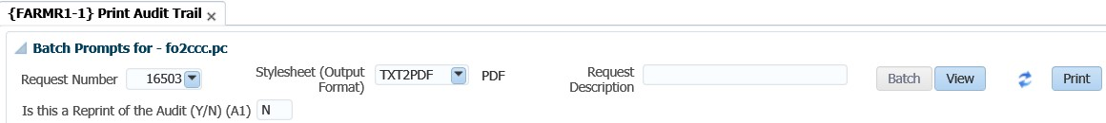

## Print User Work Summary {FARMR1-2}

This report can be used to reconcile input documents with the transactions processed by users in the system for a specific period.

This is the option that will be used to determine who made changes to code structures in the AR system. It will not only show who made changes but also the date and time changes were made.

**See Example below {FARMR1-2}**

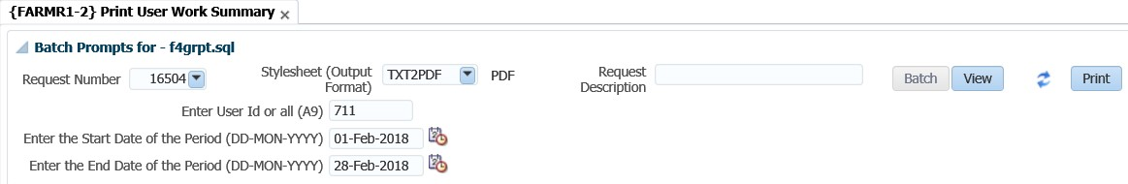

**See Example below {FARMR1-21}**

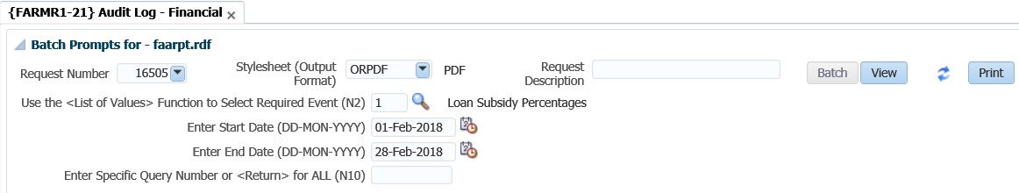

## Balances: Aged {FAROR1-4}

This report will be used to get a list of debtors balances up to a specific date (or year and cycle).

**See Example below {FAROR1-4}**

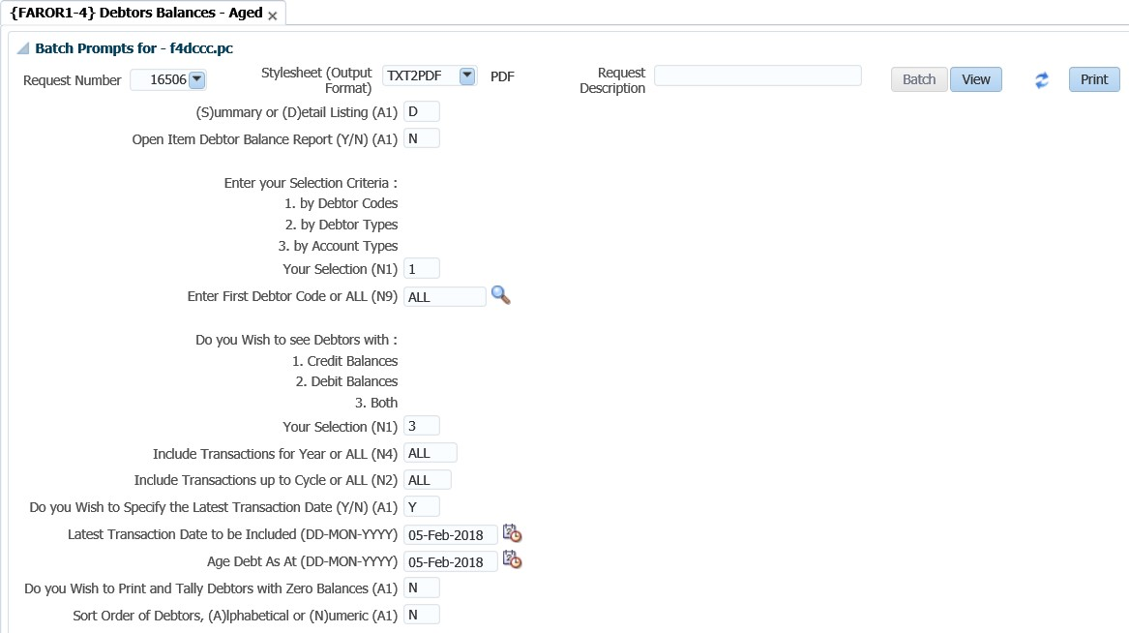

## Consolidated Debtor Statement {FAROR1-9}

This option is used to run consolidated statements. Where the open item functionality is used, you can print a statement that will indicate only the outstanding transactions.

**See Example below {FAROR1-9}**

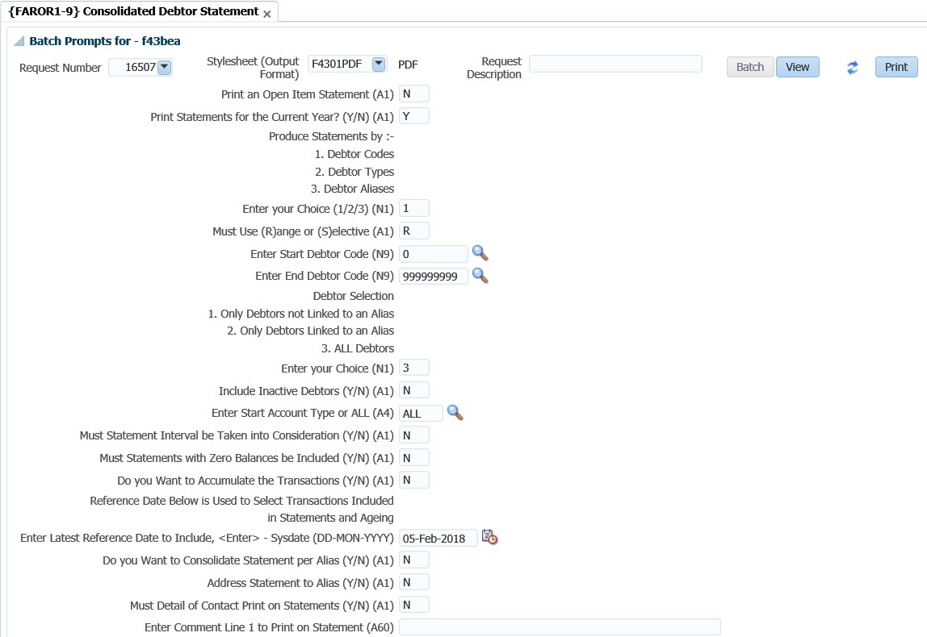

## Consolidated Internal Debtor Statement {FAROR1-11}

This option is based on the selections criteria of previous debtor statements. It is designed for internal use only and the output is based on the iComms concept. The users may design their own layout.

**See Example below {FAROR1-11}**

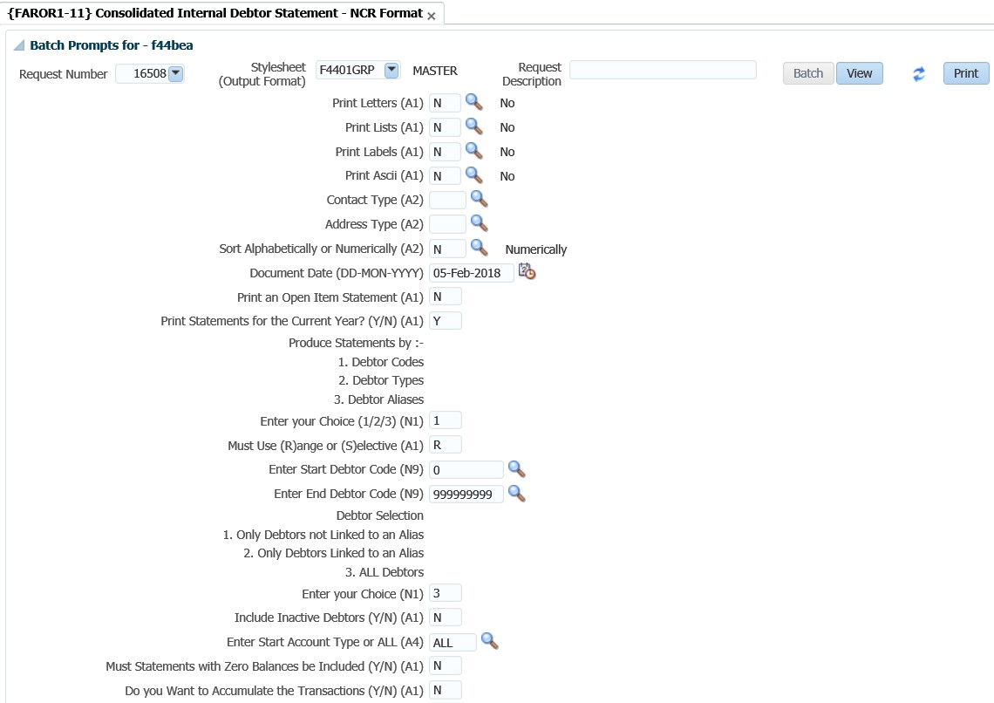

## Transaction per Type {FAROR1-23}

This report is used to retrieve all transaction per transaction type, which had an impact on the AR system. It will typically be used when you reconcile the subsystem with the GL and you need to compare the transactions per TT between the subsystem and the GL.

**See Example below {FAROR1-23}**

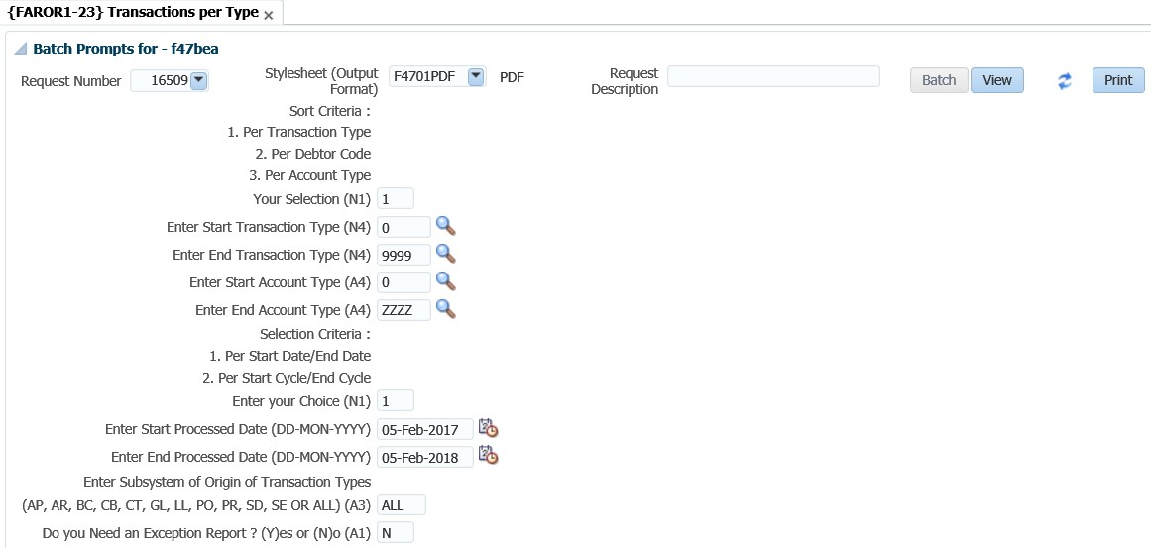

## Print AR Journals in Process {FAROR1-29}

This report is used to view specific completed batch journals processed on {FARO-29}. (i.e A journal where the total on the first tab balanced with the individual transactions on the second tab).

**See Example below {FAROR1-29}**

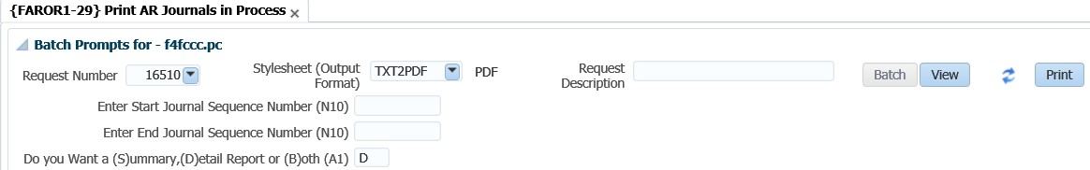

# Acronyms, Glossary & Terminology

## Acronyms

|  |  |
| --- | --- |
| **Acronym** | **Definition** |
| **DSL** | Data Sheet Layout (spreadsheet format of selected applications) |
| **DSR** | Document Storage and Retrieval |
| **EP** | Entry Point |
| **ES** | Entry Screen (menu/front end) |
| **i-Comms** | I-Communications - New Implementation of Selected Letters, Lists and Labels via Desktop Integration. I.e. Creating Letters with a Word Processing Application outside the ITS Back-Office System. |
| **i-Grams** | A Visual Representation of Complex Data for Simplification. |
| **LOV** | List of Values |
| **OID** | Oracle Internet Directory |
| **PCL** | Printer Controlled Language |
| **PoE** | Portfolio of Evidence |
| **SMS** | Student Management System |
| **SSO** | Single Sign On |
| **URL** | Uniform Resource Locator. Usually pronounced by sounding out each letter but, in some quarters, pronounced "Earl" - is the unique address for a file that is accessible on the Internet. |
| **XML** | Extensible Mark-up Language. A mark-up language like HTML, used in reporting and iComms |
| **XSL** | Extensible Style sheet Language. A style sheet defining the output format of XML |

## Glossary

|  |  |
| --- | --- |
| **Term** | **Definition** |
| **Tab** | A section of screen that displays related information associated with a record. |
| **Canvas** | Any ‘white space’ on a screen. Right-clicking on the canvas usually offers additional options. |
| **Database** | An electronic system of storing and retrieving information so that it can be displayed according to a number of predetermined formats. |
| **Execute query** | The act of conveying search criteria to retrieve and display selected data. |
| **Field** | A box on the screen that displays numeric or alphanumeric information, or permits numeric or alphanumeric information to be entered. |
| **List of**  **Values** | A list of codes (numeric or alphanumeric) accessible through menus in certain fields.  **Note:** Is represented by an ellipsis or at the end of the field. |
| **Output** | The displayed or printed result by which information is requested from the database through a query or entered search criteria. |
| **Query** | A database term for a search carried on one or more fields on a screen. |
| **Query**  **criteria** | Search criteria used in a query. |
| **Record** | A data structure composed of one or more fields. |
| **Report** | The displayed or printed output resulting from report criteria used to generate a report. |
| **Report query** | Criteria used to search the database so that a report is generated. |

## Terminology

|  |  |
| --- | --- |
| **Term** | **Definition** |
| **Academic structure** | This is the structure of all academic qualifications / study programs offered by a university, linked to a faculty, then to an academic department, and then linking all the subjects / courses / modules that form part of the curriculum to the qualification / program. It includes all pre- and co-requisites per subject / course, credits per subject / course / module, formats of offering and all relevant information related to the completion of a particular qualification, i.e. degree, diploma, etc. This structure is maintained on the university’s student information system. |
| **Analyse** | Interpretation  Apply of processes  Examine, Investigate, Consider, Evaluate or Scrutinizes |
| **Tab** | A section of screen that displays related information associated with a record. |
| **Calculate** | Compute |
| **Canvas** | Any ‘white space’ on a screen. Right-clicking on the canvas usually offers additional options. |
| **Compile** | Collect, Assemble, Accumulate or Gather |
| **Copy** | Duplicate |
| **Database** | An electronic system of storing and retrieving information so that it can be displayed according to a number of predetermined formats. |
| **Dean** | The person who has been appointed by the university as the academic head of a faculty. |
| **Department** | A sub-section of a faculty’s organizational structure, based on an academic field and / or main subject, whereas the particular department is responsible for the qualifications or study programs that are linked to the field or main subject. An academic department is headed up by a Head of Department (HOD). |
| **Execute query** | The act of conveying search criteria to retrieve and display selected data. |
| **Faculty** | A sub-section of a university’s academic structure, based on a collective but related number of study fields or subjects, e.g. Faculty of Medicine. A faculty is headed up by a Dean. |
| **Faculty**  **Administrator** | The person who has been appointed to execute the administrative functions of a faculty that includes inter alia student administration, financial administration and committee administration. |
| **Faculty**  **Manager** | The person who has been appointed to manage the overall administrative functions of a faculty, and who is a member of the faculty’s executive management team. |
| **Field** | A box on the screen that displays numeric or alphanumeric information, or permits numeric or alphanumeric information to be entered. |
| **Generate** | Create or Delete Data  Compute Results  Adjust Results |
|  | Print or Run a Report  Print or Run a List  Print or Run a Letter  Print or Run a Label  Print or Run a Log File |
| **HOD** | The person who is appointed as the head of an academic department. |
| **List of Values** | A list of codes (numeric or alphanumeric) accessible through menus in certain fields.  **Note:** Is represented by an ellipsis or at the end of the field. |
| **Maintain** | Create, Capture, Insert or Enter Records  Delete, Purge Records  Update, Change or Rectify Records |
| **Output** | The displayed or printed result by which information is requested from the database through a query or entered search criteria. |
| **Query** | A database term for a search carried on one or more fields on a screen. |
| **Query criteria** | Search criteria used in a query. |
| **Record** | A data structure composed of one or more fields. |
| **Report** | The displayed or printed output resulting from report criteria used to generate a report. |
| **Report query** | Criteria used to search the database so that a report is generated. |
| **Rollback** | Reversal |
| **Screen** | All that relates to data can be displayed or entered in fields in one or more tabs. |
| **Utilize** | Query, View, Understand or Use Information |
| **Verify** | Check, Control, Confirm or Validate Information |

# Help us enhance the course

After completing the Accounts Receivable training, we would appreciate it if you take a few moments to give us your feedback on any aspect of this course. Your feedback might include comments on:

* Course content and structure.
* Course reading materials and resources.
* Course duration.
* Course support (assigned tutors, technical help, etc.)

Your constructive feedback will help us to improve and enhance this course.

Need help?

You can refer to our online help manual available on the system or alternatively contact Adapt IT – Education: Consulting and Training

**Physical Address**

152 14th Rd

Noordwyk

Midrand, 1687

Johannesburg

South Africa

**Tel**: +27 (10) 494 0000

**Email**: EDU.consulting@adaptit.co.za

**Website**: [www.adaptit.co.za](http://www.adaptit.co.za/)